Hortonworks Installation on Centos7

HDP Setup and Configuration

12/5/2016

Shalaj Shukla

Contents

Setup http server 2

Setup Pre-requisites 3

Host Machines Configuration 3

Disable Firewall (IPTables) 4

Enabling NTP 4

Set umask to 022 7

SSH Password less sudo Access 7

Set swappiness to 10 10

Disabling SELinux 12

Download ambari repo and hdp.repo File 14

Setup Local yum repository for Hortonworks 18

Configure ambari.repo and hdp.repo file 24

Install ambari server 26

Add Ambari Metric and Zookeeper Service 42

Add HDFS Service 50

Add Yarn Service 58

Add Tez Service 66

Add Hive Service 74

# Setup http server

If httpd service is not installed please install it using below command

|  |
| --- |
| yum install httpd |

Make sure httpd service starts automatically at boot time, use the following command:

|  |
| --- |
| systemctl enable httpd.service |

First just start the httpd service and test the home page

|  |
| --- |
| systemctl start httpd.service |

Go to browser and visit **http:<host IP>:port** , in our case it is [**http://172.27.155.92:80**](http://172.27.155.92:80)and check if service is running properly

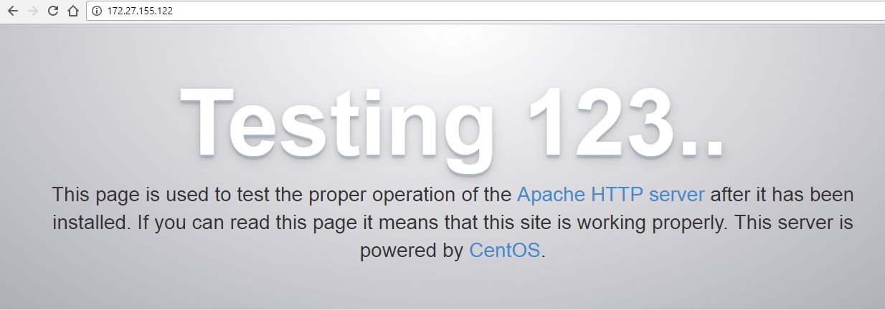

If you find this page it means service is running properly

We can also check if port 80 is listening by using telnet command

Check if http server is working or not using telnet command

|  |
| --- |
| telnet localhost 80 |

If telnet is not installed, install telnet service first

|  |
| --- |
| yum -y install telnet |

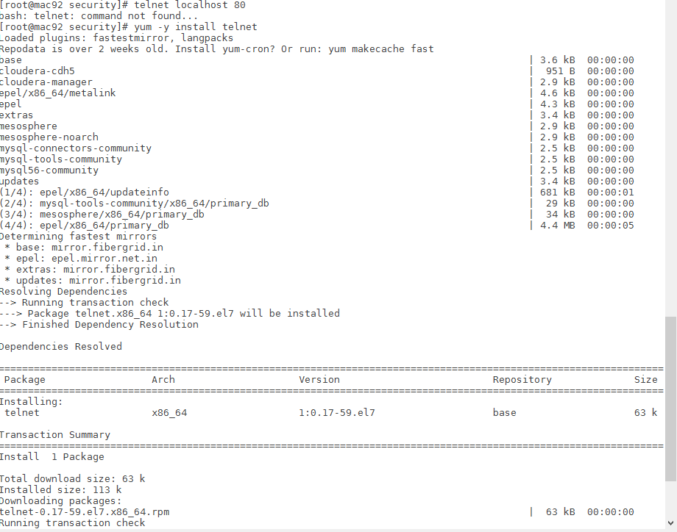

Now check it again

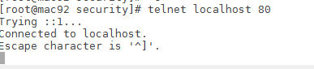

It is working; enter exit to exit from telnet

## Setup Pre-requisites

### Host Machines Configuration

Here we are planning to setup single node cluster on centos 7 machine (172.27.155.92)

Update /etc/hosts file

|  |
| --- |
| 127.0.0.1 localhost localhost.localdomain localhost4 localhost4.localdomain4  ::1 localhost localhost.localdomain localhost6 localhost6.localdomain6  172.27.155.92 mac92.cybage.com mac92 |

***Note: please do not put any special character in hostname only alphabets, digits and hyphen allowed***

Also please set hostname permanently by issuing following command in all nodes

|  |
| --- |
| ***#*** hostnamectl set-hostname <Your-New-Host-Name-Here> |

### Disable Firewall (IPTables)

Disable firewall by issuing command below

|  |
| --- |
| [root@mac122 cloudera-scm-server]# systemctl disable firewalld  Removed symlink /etc/systemd/system/dbus-org.fedoraproject.FirewallD1.service.  Removed symlink /etc/systemd/system/basic.target.wants/firewalld.service.  [root@mac122 cloudera-scm-server]# systemctl stop firewalld  [root@mac122 cloudera-scm-server]# |

For Redhat 6 version please use below commands

|  |
| --- |
| # service iptables stop # chkconfig iptables off  # service ip6tables stop # chkconfig ip6tables off |

### Enabling NTP

CDH requires that you configure the Network Time Protocol (NTP) service on each machine in your cluster. To start NTP and configure it to run automatically on reboot, perform the following steps on each node in your cluster.

1. Install NTP if it is not installed already

|  |
| --- |
| # yum -y install ntp |

2. Open the /etc/ntp.conf file and copy one of the server name that we use later

|  |
| --- |
| # For more information about this file, see the man pages  # ntp.conf(5), ntp_acc(5), ntp_auth(5), ntp_clock(5), ntp_misc(5), ntp_mon(5).  driftfile /var/lib/ntp/drift  # Permit time synchronization with our time source, but do not  # permit the source to query or modify the service on this system.  restrict default nomodify notrap nopeer noquery  # Permit all access over the loopback interface. This could  # be tightened as well, but to do so would effect some of  # the administrative functions.  restrict 127.0.0.1  restrict ::1  # Hosts on local network are less restricted.  #restrict 192.168.1.0 mask 255.255.255.0 nomodify notrap  # Use public servers from the pool.ntp.org project.  # Please consider joining the pool (http://www.pool.ntp.org/join.html).  server 0.centos.pool.ntp.org iburst  server 1.centos.pool.ntp.org iburst  server 2.centos.pool.ntp.org iburst  server 3.centos.pool.ntp.org iburst  #broadcast 192.168.1.255 autokey # broadcast server  #broadcastclient # broadcast client  #broadcast 224.0.1.1 autokey # multicast server  #multicastclient 224.0.1.1 # multicast client  #manycastserver 239.255.254.254 # manycast server  #manycastclient 239.255.254.254 autokey # manycast client  # Enable public key cryptography.  #crypto  includefile /etc/ntp/crypto/pw  # Key file containing the keys and key identifiers used when operating  # with symmetric key cryptography.  keys /etc/ntp/keys  # Specify the key identifiers which are trusted.  #trustedkey 4 8 42  # Specify the key identifier to use with the ntpdc utility.  #requestkey 8  # Specify the key identifier to use with the ntpq utility.  #controlkey 8  # Enable writing of statistics records.  #statistics clockstats cryptostats loopstats peerstats  # Disable the monitoring facility to prevent amplification attacks using ntpdc  # monlist command when default restrict does not include the noquery flag. See  # CVE-2013-5211 for more details.  # Note: Monitoring will not be disabled with the limited restriction flag. |

3. Configure the NTP service to run at reboot.

|  |
| --- |
| chkconfig ntpd on |

4. Start and enable the NTP service

|  |
| --- |
| #systemctl start ntpd  #systemctl enable ntpd |

5. Synchronize the node

|  |
| --- |
| #ntpdate -u <your_ntp_server> |

In our case

ntpdate -u 0.centos.pool.ntp.org

6. Synchronize the system clock (to prevent synchronization problems).

|  |
| --- |
| #hwclock --systohc |

7. Check ntpstat

|  |
| --- |
| [root@mac122 ~]# ntpstat  synchronised to NTP server (123.108.200.124) at stratum 4  time correct to within 8130 ms  polling server every 64 s |

8. Check list of server

|  |
| --- |
| [root@mac122 ~]# ntpq -pn  remote refid st t when poll reach delay offset jitter  ==============================================================================  139.59.45.40 .INIT. 16 u - 64 0 0.000 0.000 0.000  *123.108.200.124 195.219.205.9 3 u 38 64 17 33.051 24.723 41.028  139.59.19.184 .INIT. 16 u - 64 0 0.000 0.000 0.000  139.59.61.225 .INIT. 16 u - 64 0 0.000 0.000 0.000 |

Here server with * is configured server

### Set umask to 022

By default umask value is 022 so that every file will be created with 755 permission

If it is not configured to 022 please update it accordingly

|  |
| --- |
| [root@mac92 ~]# umask  0022  [root@mac92 ~]# umask 022  [root@mac92 ~]# umask  0022 |

### SSH Password less sudo Access

In case if you do not want to setup with root user, we need to create ssh password less sudo access.

Please skip this step if you are planning to install with root user

Please follow below steps to configure ssh password less sudo access

1. First we need to create a new user on each node (username should be same)

|  |
| --- |
| [root@mac248 ~]# useradd cloudera-user  [root@mac248 ~]# passwd cloudera-user  Changing password for user cloudera-user.  New password:  BAD PASSWORD: The password fails the dictionary check - it is based on a dictionary word  Retype new password:  passwd: all authentication tokens updated successfully. |

Repeat this step to all nodes

2. Run visudo command to add new user to sudoers list

|  |
| --- |
| Defaults requiretty  Defaults:cloudera-user !requiretty  #  # Refuse to run if unable to disable echo on the tty. This setting should also be  # changed in order to be able to use sudo without a tty. See requiretty above.  #  ..  ..  ..  ..  ## Next comes the main part: which users can run what software on  ## which machines (the sudoers file can be shared between multiple  ## systems).  ## Syntax:  ##  ## user MACHINE=COMMANDS  ##  ## The COMMANDS section may have other options added to it.  ##  ## Allow root to run any commands anywhere  root ALL=(ALL) ALL  cloudera-user ALL=(ALL) NOPASSWD: ALL |

Add highlighted text at proper place in file and save it

Repeat this step to all nodes

3. Now create public and private key on one of the node , first we need to switch to Cloudera-user

|  |
| --- |
| [root@mac248 ~]# su - cloudera-user  [cloudera-user@mac248 ~]$ ssh-keygen -t rsa  Generating public/private rsa key pair.  Enter file in which to save the key (/home/cloudera-user/.ssh/id_rsa):  Created directory '/home/cloudera-user/.ssh'.  Enter passphrase (empty for no passphrase):  Enter same passphrase again:  Your identification has been saved in /home/cloudera-user/.ssh/id_rsa.  Your public key has been saved in /home/cloudera-user/.ssh/id_rsa.pub.  The key fingerprint is:  66:9a:b5:ab:a9:b6:06:50:cc:9d:6f:48:fe:0b:66:f1 cloudera-user@mac248  The key's randomart image is:  +--[ RSA 2048]----+  | o . . |  | + + |  | . o o |  |. + o |  | . = S |  | . + E* . |  | + .o.. |  | o .. . |  | oooo.. |  +-----------------+ |

4. Check if files are created successfully under .ssh folder

|  |
| --- |
| [cloudera-user@mac248 ~]$ ls -la  total 24  drwx------ 3 cloudera-user cloudera-user 4096 Apr 21 20:52 .  drwxr-xr-x. 6 root root 4096 Apr 21 20:44 ..  -rw-r--r-- 1 cloudera-user cloudera-user 18 Dec 7 04:49 .bash_logout  -rw-r--r-- 1 cloudera-user cloudera-user 193 Dec 7 04:49 .bash_profile  -rw-r--r-- 1 cloudera-user cloudera-user 231 Dec 7 04:49 .bashrc  drwx------ 2 cloudera-user cloudera-user 4096 Apr 21 20:52 .ssh  [cloudera-user@mac248 ~]$ cd .ssh  [cloudera-user@mac248 .ssh]$ ls -l  total 8  -rw------- 1 cloudera-user cloudera-user 1675 Apr 21 20:52 id_rsa  -rw-r--r-- 1 cloudera-user cloudera-user 402 Apr 21 20:52 id_rsa.pub |

5. Now create authorized_keys file on each of the node by issuing command below

|  |
| --- |
| [cloudera-user@mac248 .ssh]$ ssh-copy-id -i /home/cloudera-user/.ssh/id_rsa.pub cloudera-user@172.27.155.71  The authenticity of host '172.27.155.71 (172.27.155.71)' can't be established.  ECDSA key fingerprint is e8:61:2c:01:63:4e:0e:08:06:de:fb:be:be:57:82:7f.  Are you sure you want to continue connecting (yes/no)? yes  /bin/ssh-copy-id: INFO: attempting to log in with the new key(s), to filter out any that are already installed  /bin/ssh-copy-id: INFO: 1 key(s) remain to be installed -- if you are prompted now it is to install the new keys  cloudera-user@172.27.155.71's password:  Number of key(s) added: 1  Now try logging into the machine, with: "ssh 'cloudera-user@172.27.155.71'"  and check to make sure that only the key(s) you wanted were added. |

Same step we need to perform on each node including the node on which you created public and private key

|  |
| --- |
| [cloudera-user@mac248 .ssh]$ ssh-copy-id -i /home/cloudera-user/.ssh/id_rsa.pub cloudera-user@172.27.155.248  The authenticity of host '172.27.155.248 (172.27.155.248)' can't be established.  ECDSA key fingerprint is fd:c8:7e:95:da:8f:37:57:de:47:d8:d0:75:4b:80:e3.  Are you sure you want to continue connecting (yes/no)? yes  /bin/ssh-copy-id: INFO: attempting to log in with the new key(s), to filter out any that are already installed  /bin/ssh-copy-id: INFO: 1 key(s) remain to be installed -- if you are prompted now it is to install the new keys  cloudera-user@172.27.155.248's password:  Number of key(s) added: 1  Now try logging into the machine, with: "ssh 'cloudera-user@172.27.155.248'"  and check to make sure that only the key(s) you wanted were added. |

Here we are creating authorized_keys file on same node

6. Now run below command to ensure if SSH password less sudo access has been established

|  |
| --- |
| [cloudera-user@mac248 .ssh]$ ssh cloudera-user@172.27.155.71 sudo ls -l  total 0  [cloudera-user@mac248 .ssh]$ |

If command runs without asking password it means it is working fine ( run this command for all nodes)

7. Just to verify, check on each node if authorized_keys file is created under .ssh folder

|  |
| --- |
| [root@mohammadkhan-w8 .ssh]# su -cloudera-user  bash: loudera-user: command not found  [root@mohammadkhan-w8 .ssh]# su - cloudera-user  [cloudera-user@mac71 ~]$ cd .ssh  [cloudera-user@mac71 .ssh]$ ls -l  total 4  -rw------- 1 cloudera-user cloudera-user 402 Apr 21 15:29 authorized_keys |

### Set swappiness to 10

Check swappiness value

|  |
| --- |
| [root@mac122 log]# sysctl vm.swappiness  vm.swappiness = 60 |

OR

|  |
| --- |
| [root@mac53 etc]# cat /proc/sys/vm/swappiness  60 |

It means it’s going to start swapping out when 40% of physical memory is used

You can change swappiness value by editing /etc/sysctl.conf file

Add line add the end of file vm.swappiness = <value> like vm.swappiness = 10

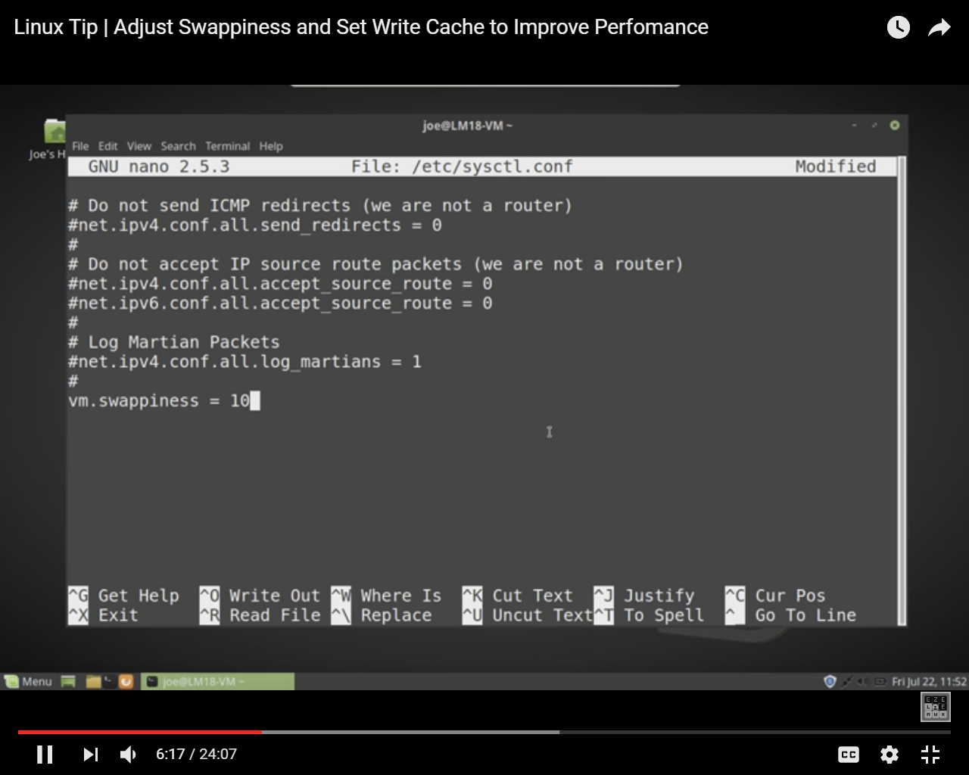

Cloudera recommended assigning 10 to swappiness

Reboot system

### Disabling SELinux

First you need to disable SELinux before installing Cloudera manager

Security-Enhanced Linux (SELinux) allows you to set access control through policies. You must disable SELinux on each host before you deploy CDH on your cluster.

To disable SELinux, perform the following steps on each host.

1. Check the SELinux state.

getenforce

If the output is disabled, you can skip this task, if the output is enforcing, continue to the next step.

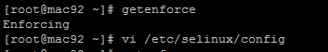

Or you can check sestatus command

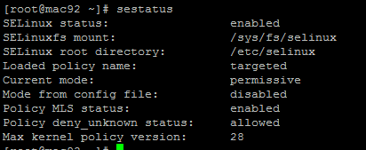

1. Open the /etc/selinux/config file (in some systems, the /etc/sysconfig/selinux file).

Change the line SELINUX=enforcing to SELINUX=disabled.

1. Save and close the file.
2. Reboot machine by reboot command

After reboot, you can verify the status of SELinux. Issue “sestatus” command to verify that SELinux permanently disabled:

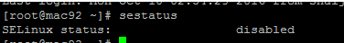

Or you can check by getenforce command

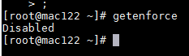

# Download ambari repo and hdp.repo File

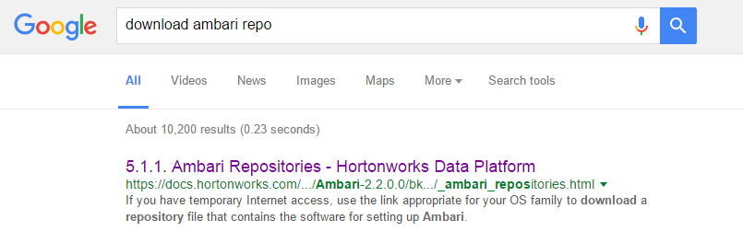

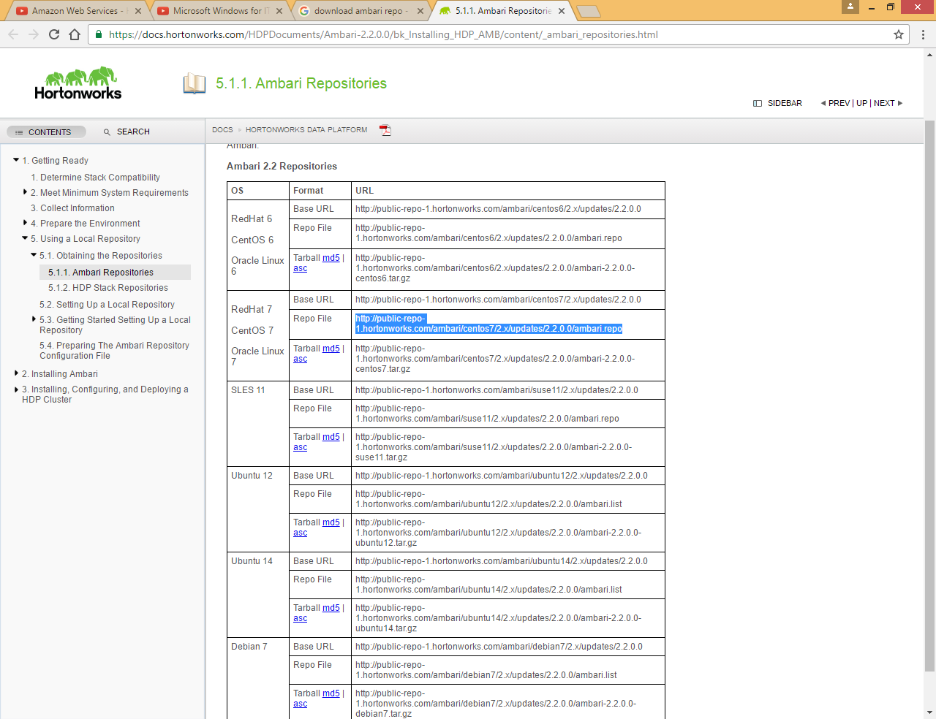

Choose correct version of OS

Run below command to place it under yum folder

|  |
| --- |
| sudo wget -nv <http://public-repo-1.hortonworks.com/ambari/centos7/2.x/updates/2.2.0.0/ambari.repo> -O /etc/yum.repos.d/ambari.repo |

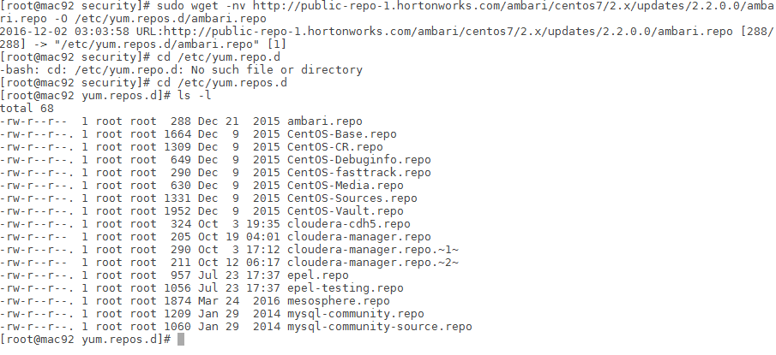

Now click on hdp stack repository link to get the hdp.repo file

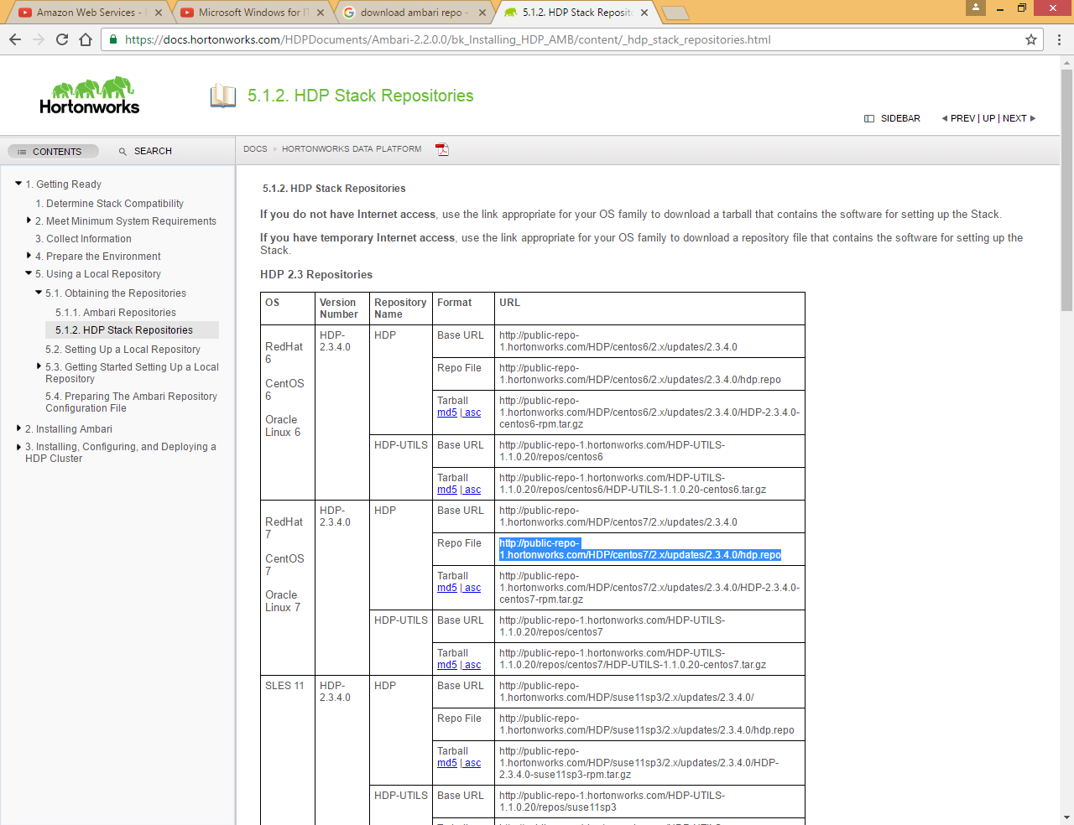

|  |
| --- |
| sudo wget -nv <http://public-repo-1.hortonworks.com/HDP/centos7/2.x/updates/2.3.4.0/hdp.repo> -O /etc/yum.repos.d/hdp.repo |

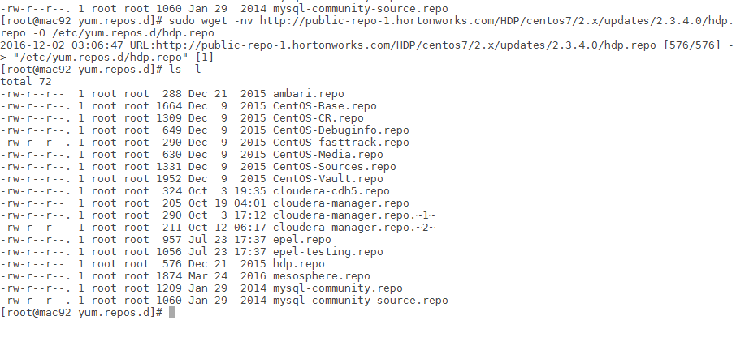

|  |
| --- |
| [root@mac92 yum.repos.d]# cat ambari.repo  #VERSION_NUMBER=2.2.0.0-1310  [Updates-ambari-2.2.0.0]  name=ambari-2.2.0.0 - Updates  baseurl=http://public-repo-1.hortonworks.com/ambari/centos7/2.x/updates/2.2.0.0  gpgcheck=1  gpgkey=http://public-repo-1.hortonworks.com/ambari/centos7/RPM-GPG-KEY/RPM-GPG-KEY-Jenkins  enabled=1  priority=1 |

|  |
| --- |
| [root@mac92 yum.repos.d]# cat hdp.repo  #VERSION_NUMBER=2.3.4.0-3485  [HDP-2.3.4.0]  name=HDP Version - HDP-2.3.4.0  baseurl=http://public-repo-1.hortonworks.com/HDP/centos7/2.x/updates/2.3.4.0  gpgcheck=1  gpgkey=http://public-repo-1.hortonworks.com/HDP/centos7/2.x/updates/2.3.4.0/RPM-GPG-KEY/RPM-GPG-KEY-Jenkins  enabled=1  priority=1  [HDP-UTILS-1.1.0.20]  name=HDP Utils Version - HDP-UTILS-1.1.0.20  baseurl=http://public-repo-1.hortonworks.com/HDP-UTILS-1.1.0.20/repos/centos7  gpgcheck=1  gpgkey=http://public-repo-1.hortonworks.com/HDP/centos7/2.x/updates/2.3.4.0/RPM-GPG-KEY/RPM-GPG-KEY-Jenkins  enabled=1  priority=1 |

# Setup Local yum repository for Hortonworks

Here we are setting up the local repository for Hortonworks so that in future if someone want to install Hortonworks on their machine they can refer this instead of downloading all required software from internet, it will save time

We want to download all required software under http server so that later we can use this repository to setup ambari server

By default context root for http server is /var/www/html

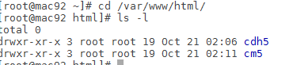

Here we can see cdh5 and cm5 folder which are related to Cloudera repository

So to separate them we will create a new folder namely horton in this folder

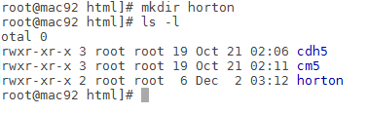

Now we need to download ambari hdp and hdp utils tar files from web

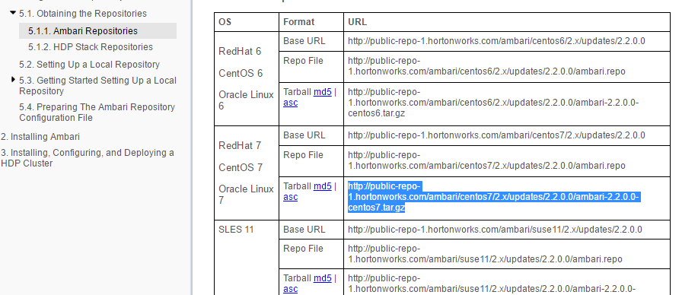

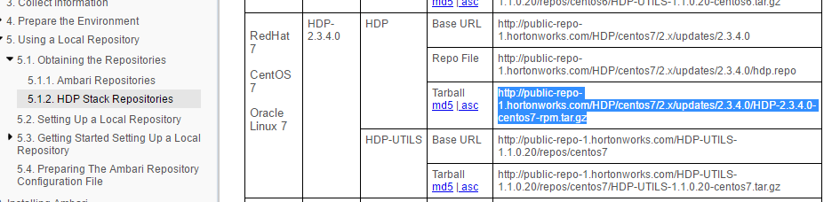

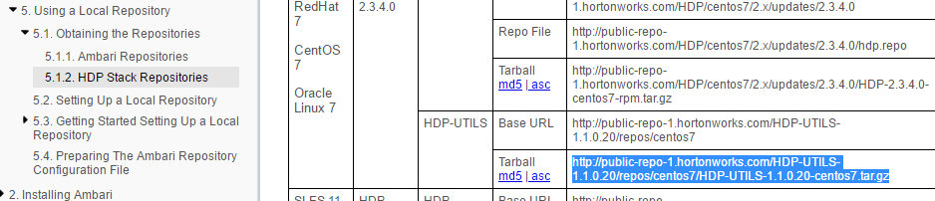

Copy all three links and run below command under /var/www/html/horoton, we will run all three commands at once in background as these will take time

|  |
| --- |
| sudo nohup wget <http://public-repo-1.hortonworks.com/ambari/centos7/2.x/updates/2.2.0.0/ambari-2.2.0.0-centos7.tar.gz> &  sudo nohup wget <http://public-repo-1.hortonworks.com/HDP/centos7/2.x/updates/2.3.4.0/HDP-2.3.4.0-centos7-rpm.tar.gz> &  sudo nohup wget <http://public-repo-1.hortonworks.com/HDP-UTILS-1.1.0.20/repos/centos7/HDP-UTILS-1.1.0.20-centos7.tar.gz> & |

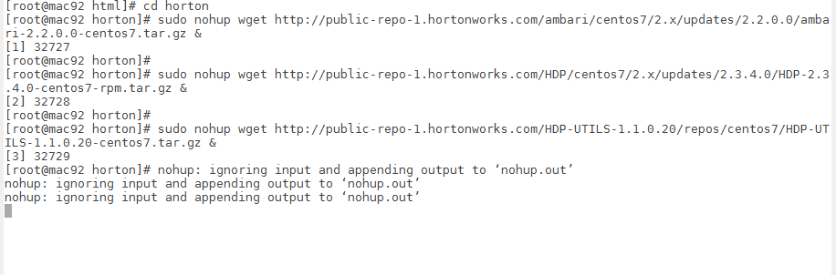

You can check if wget is running or not using below command

|  |
| --- |
| ps -ef|grep wget |

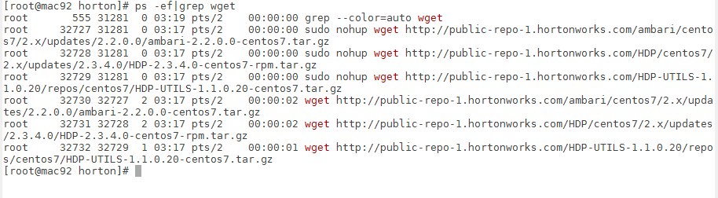

Wait for some time

Or you can also see the log file nohup.out

|  |
| --- |
| tail –f nohup.out |

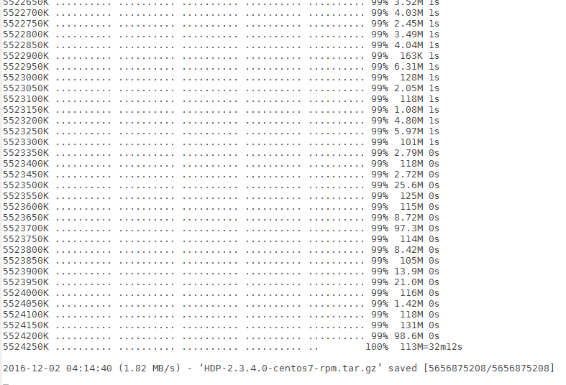

Now if you check again ps -ef|grep wget, you will find it is completed



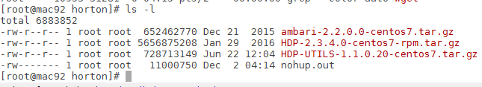

Now untar all three files in background

|  |
| --- |
| nohup sudo tar xzf ambari-2.2.0.0-centos7.tar.gz &  nohup sudo tar xzf HDP-2.3.4.0-centos7-rpm.tar.gz &  nohup sudo tar xzf HDP-UTILS-1.1.0.20-centos7.tar.gz & |

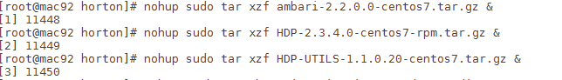

This command will also take time to untar all three files

You can check status by running below command

|  |
| --- |
| ps -ef|grep tar |

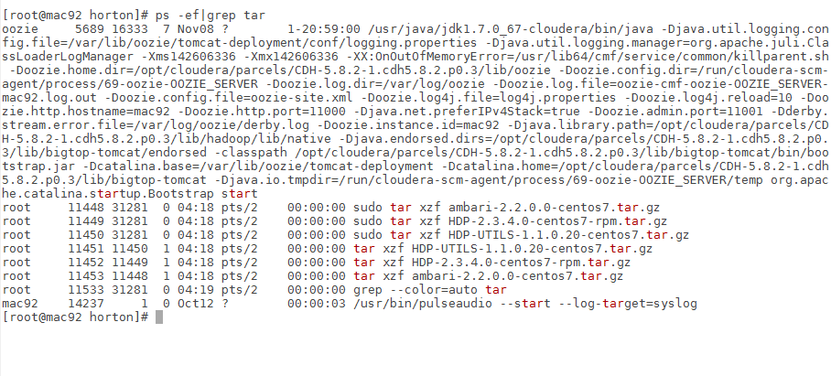

Or alternatively you can use below command to check the log status

|  |
| --- |
| tail -f nohup.out |

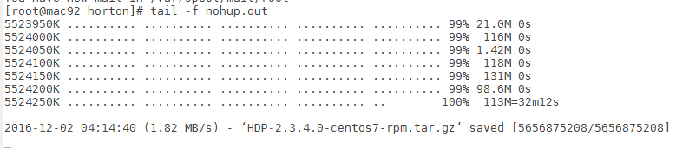

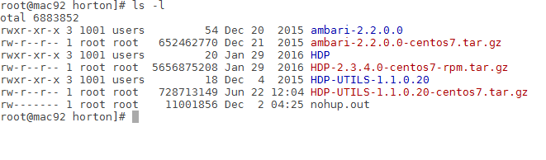

Once done remove tar.gz files

# Configure ambari.repo and hdp.repo file

Update ambari.repo and hdp.repo file according to your local yum repository path

First check **RPM-GPG-KEY-Jenkins** key location in your local yum repository

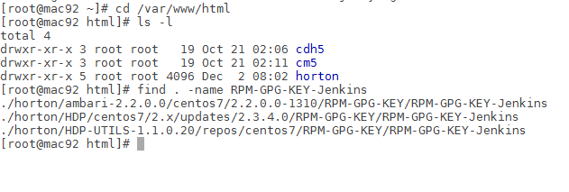

**ambari.repo file**

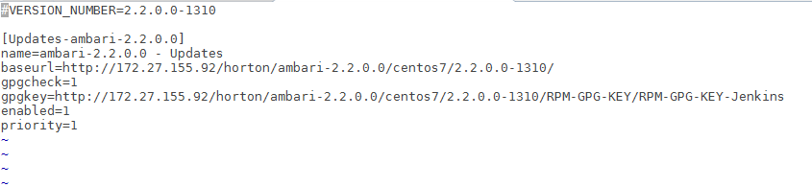

**hdp.repo file**

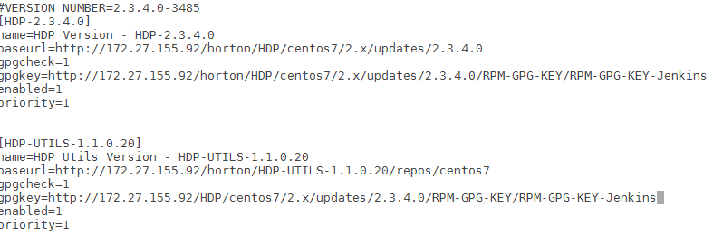

Now run ***yum repolist*** command

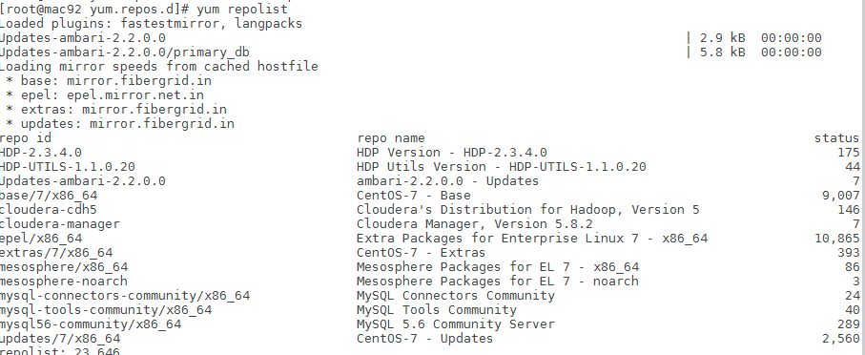

# Install ambari server

Run below command to install ambari server

|  |
| --- |
| sudo yum -y install ambari-server |

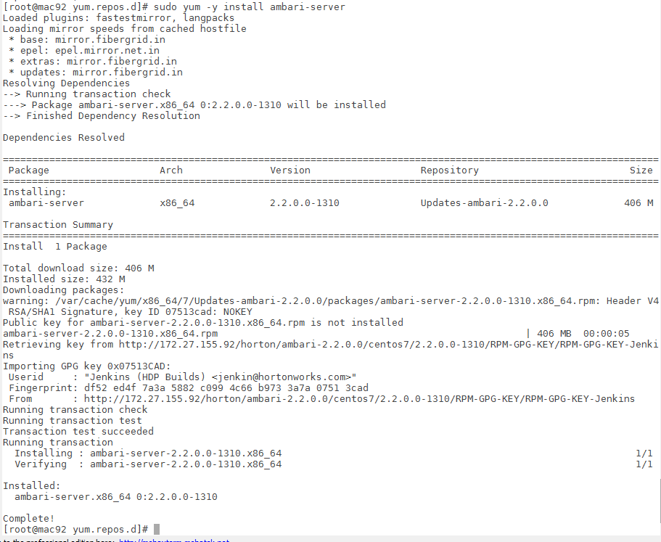

Here we can see that it is pointing to local yum repository

Now do setup for ambari server by running below command

|  |
| --- |
| sudo ambari-server setup |

Choose all default option

|  |
| --- |
| [root@mac92 yum.repos.d]# sudo ambari-server setup  Using python /usr/bin/python2  Setup ambari-server  Checking SELinux...  SELinux status is 'disabled'  Customize user account for ambari-server daemon [y/n] (n)?  Adjusting ambari-server permissions and ownership...  Checking firewall status...  Redirecting to /bin/systemctl status iptables.service  Checking JDK...  [1] Oracle JDK 1.8 + Java Cryptography Extension (JCE) Policy Files 8  [2] Oracle JDK 1.7 + Java Cryptography Extension (JCE) Policy Files 7  [3] Custom JDK  ==============================================================================  Enter choice (1):  To download the Oracle JDK and the Java Cryptography Extension (JCE) Policy Files you must accept the license terms found at http://www.oracle.com/technetwork/java/javase/terms/license/index.html and not accepting will cancel the Ambari Server setup and you must install the JDK and JCE files manually.  Do you accept the Oracle Binary Code License Agreement [y/n] (y)? y  Downloading JDK from http://public-repo-1.hortonworks.com/ARTIFACTS/jdk-8u60-linux-x64.tar.gz to /var/lib/ambari-server/resources/jdk-8u60-linux-x64.tar.gz  jdk-8u60-linux-x64.tar.gz... 100% (172.8 MB of 172.8 MB)  Successfully downloaded JDK distribution to /var/lib/ambari-server/resources/jdk-8u60-linux-x64.tar.gz  Installing JDK to /usr/jdk64/  Successfully installed JDK to /usr/jdk64/  Downloading JCE Policy archive from http://public-repo-1.hortonworks.com/ARTIFACTS/jce_policy-8.zip to /var/lib/ambari-server/resources/jce_policy-8.zip  Successfully downloaded JCE Policy archive to /var/lib/ambari-server/resources/jce_policy-8.zip  Installing JCE policy...  Completing setup...  Configuring database...  Enter advanced database configuration [y/n] (n)?  Configuring database...  Default properties detected. Using built-in database.  Configuring ambari database...  Checking PostgreSQL...  Running initdb: This may take upto a minute.  Initializing database ... OK  About to start PostgreSQL  Configuring local database...  Connecting to local database...done.  Configuring PostgreSQL...  Restarting PostgreSQL  Extracting system views...  ambari-admin-2.2.0.0.1310.jar  ......  Adjusting ambari-server permissions and ownership...  Ambari Server 'setup' completed successfully. |

Now start ambari-server

|  |
| --- |
| sudo ambari-server start |

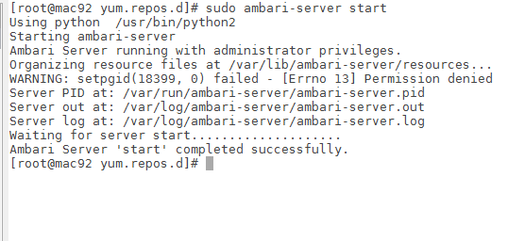

Check if ambari-server is auto start at boot time using below command

|  |
| --- |
| sudo chkconfig --list ambari-server |

And run below command to start ambari server at boot time

|  |
| --- |
| chkconfig ambari-server on |

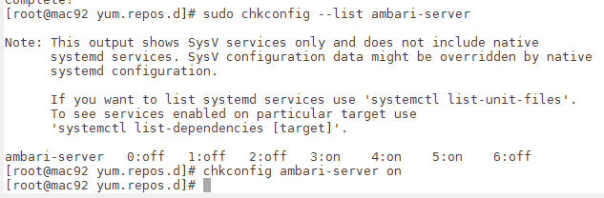

Now open <http://mac92:8080/>

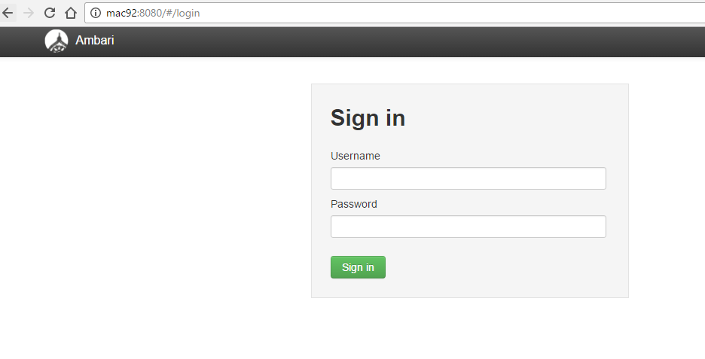

Default user name and password is admin/admin

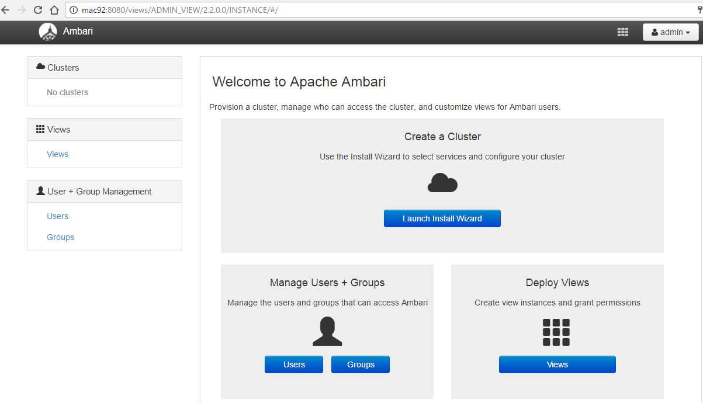

Click on Launch Install Wizard

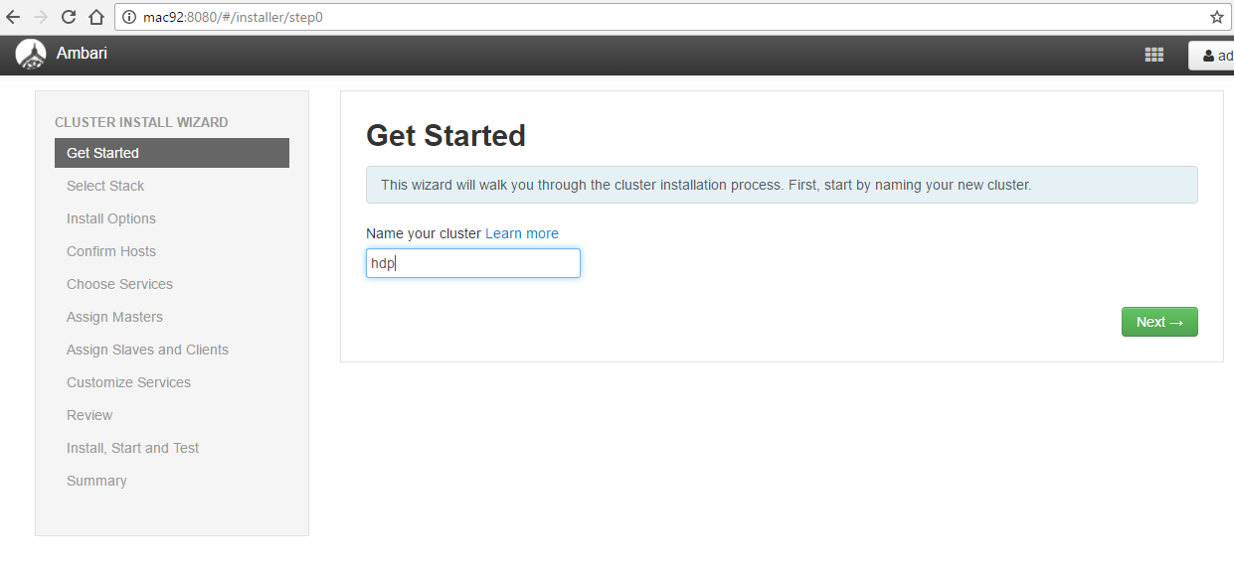

Give name of cluster

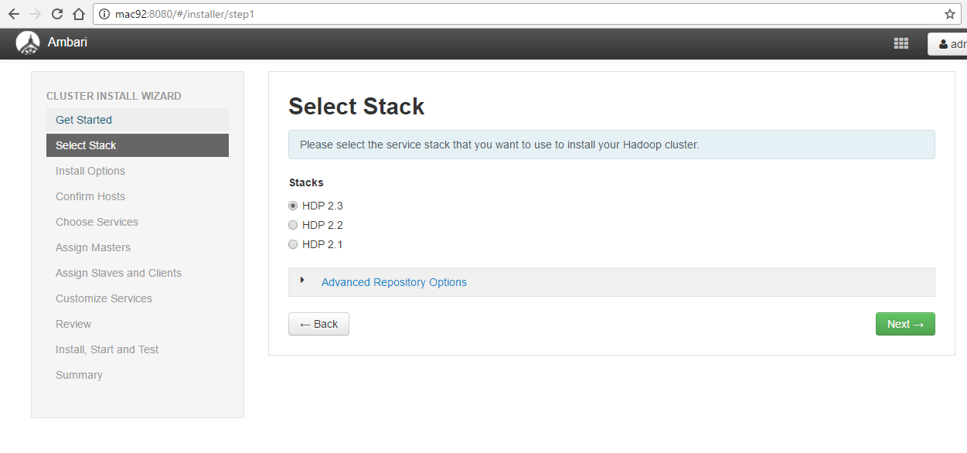

Click on Advance Repository Options

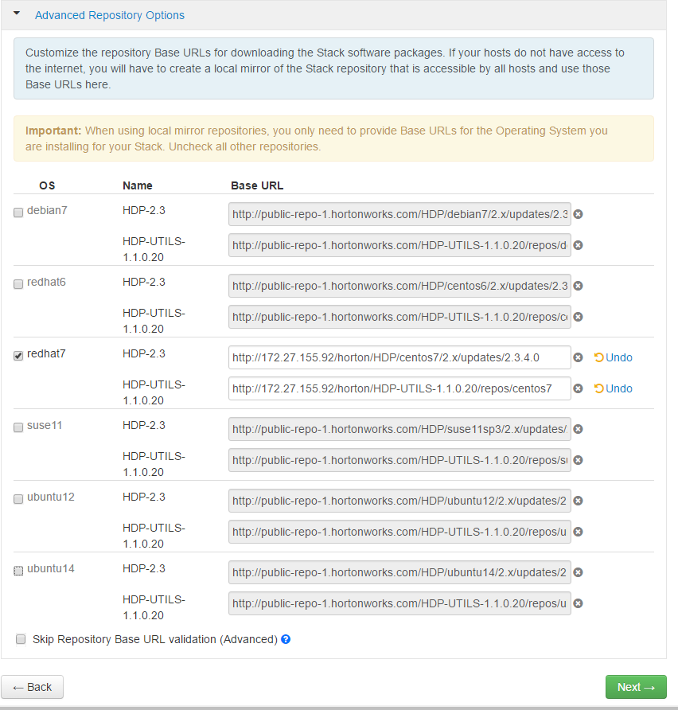

Now choose correct version of OS, in our case it is redhat 7 and deselect others, specify path of our local yum repository for hdp that we already set under hdp.repo file

|  |
| --- |
| **HDP2.3** <http://172.27.155.92/horton/HDP/centos7/2.x/updates/2.3.4.0>  **HDP-UTILS-1.1.0.20** <http://172.27.155.92/horton/HDP-UTILS-1.1.0.20/repos/centos7> |

Enter IP and private key

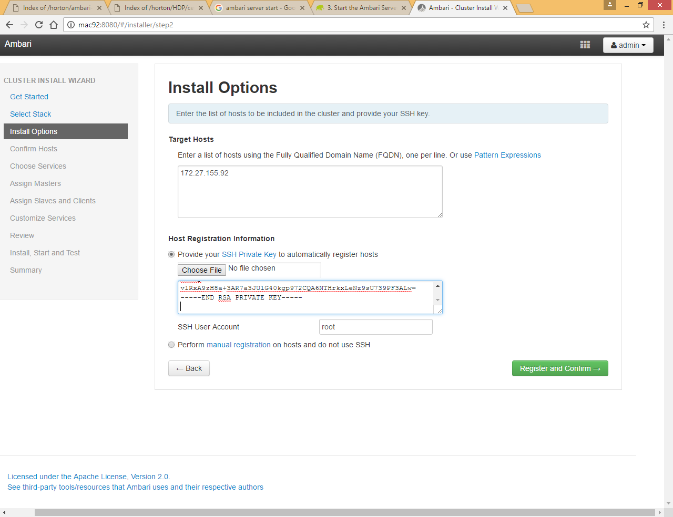

You can find private key under /.ssh/id_rsa file just copy paste the content

Note: if private key is not available you need to create new one using **ssh-keygen -t rsa** command

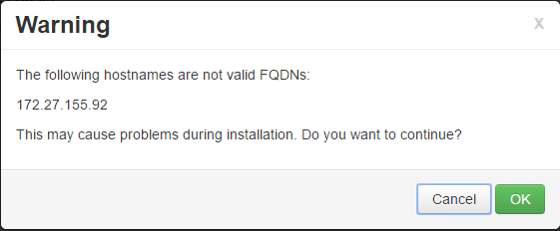

Click OK

Getting permission denied error

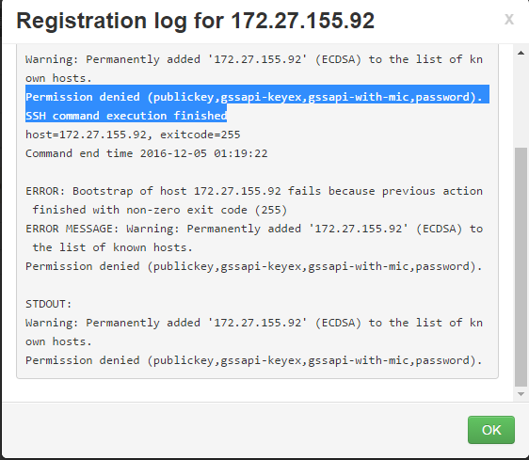

Check ssh localhost command on system and if it ask for password just follow below steps

|  |
| --- |
| cd ~/.ssh  cat id_rsa.pub >> authorized_keys |

Now again do ssh localhost

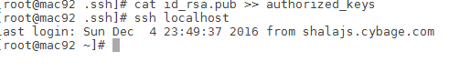

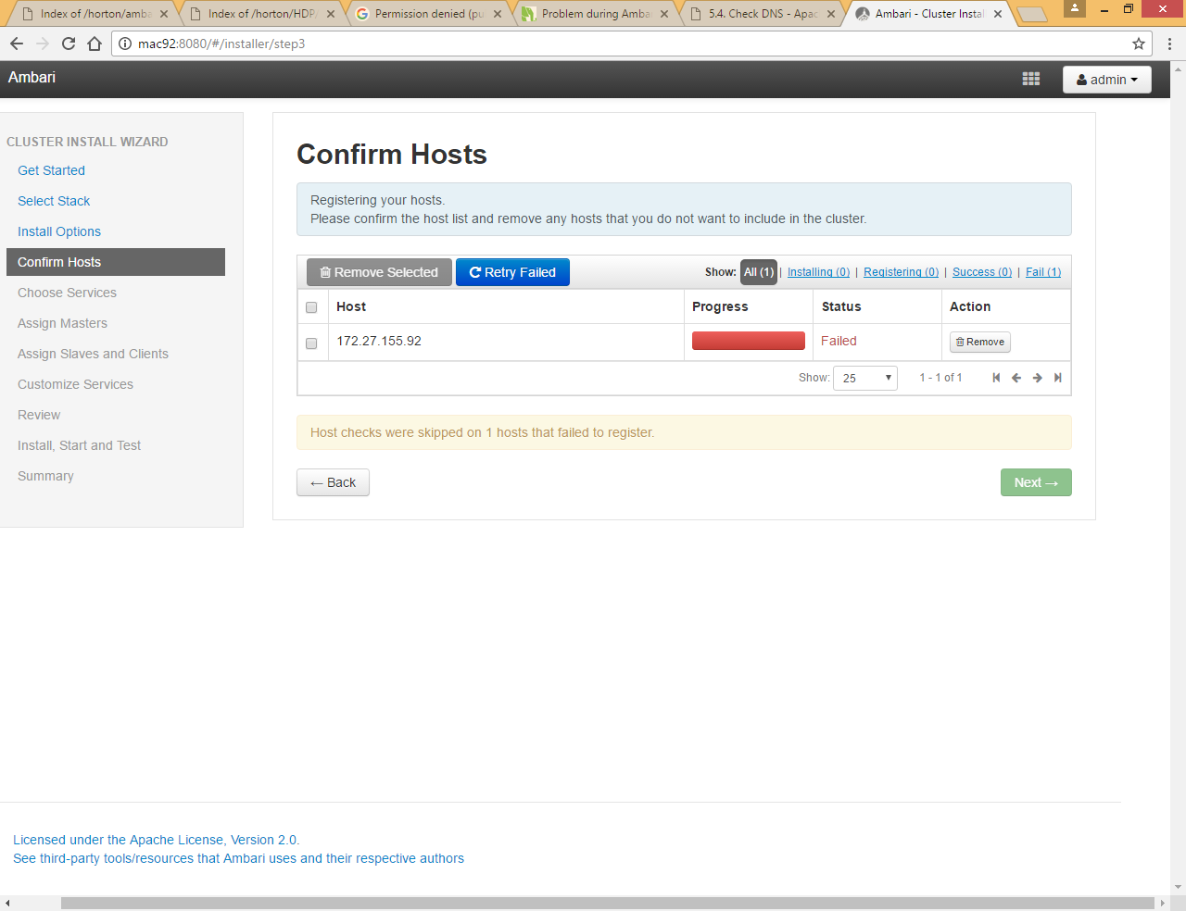

Click on Retry failed

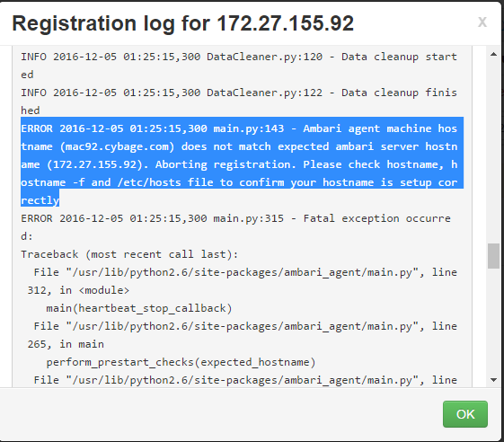

Getting above issue

We need to update the hostname properly in /etc/hosts file

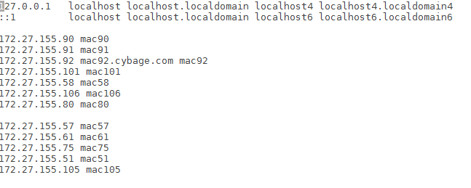

Apart from hostname we need to specify Fully Qualified Domain Name (FQDN) so please add entry like below in /etc/hosts file

172.27.155.92 mac92.cybage.com mac92

And also run **hostname mac92.cybage.com** command

Click on back and provide FQDN and click **Register and Confirm**

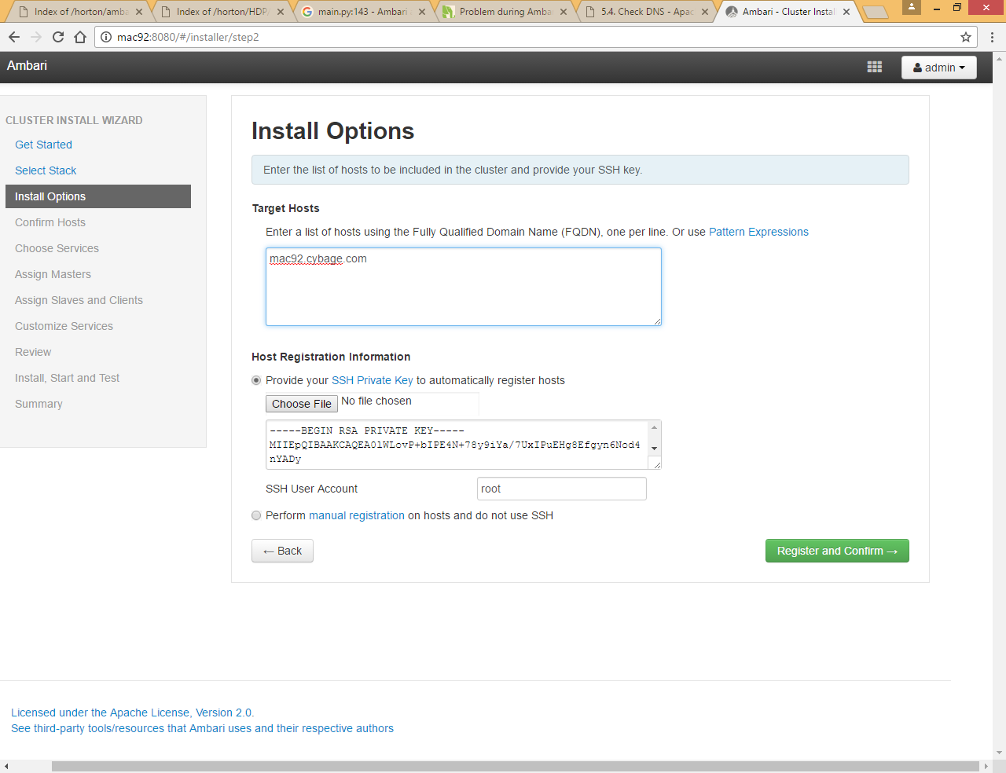

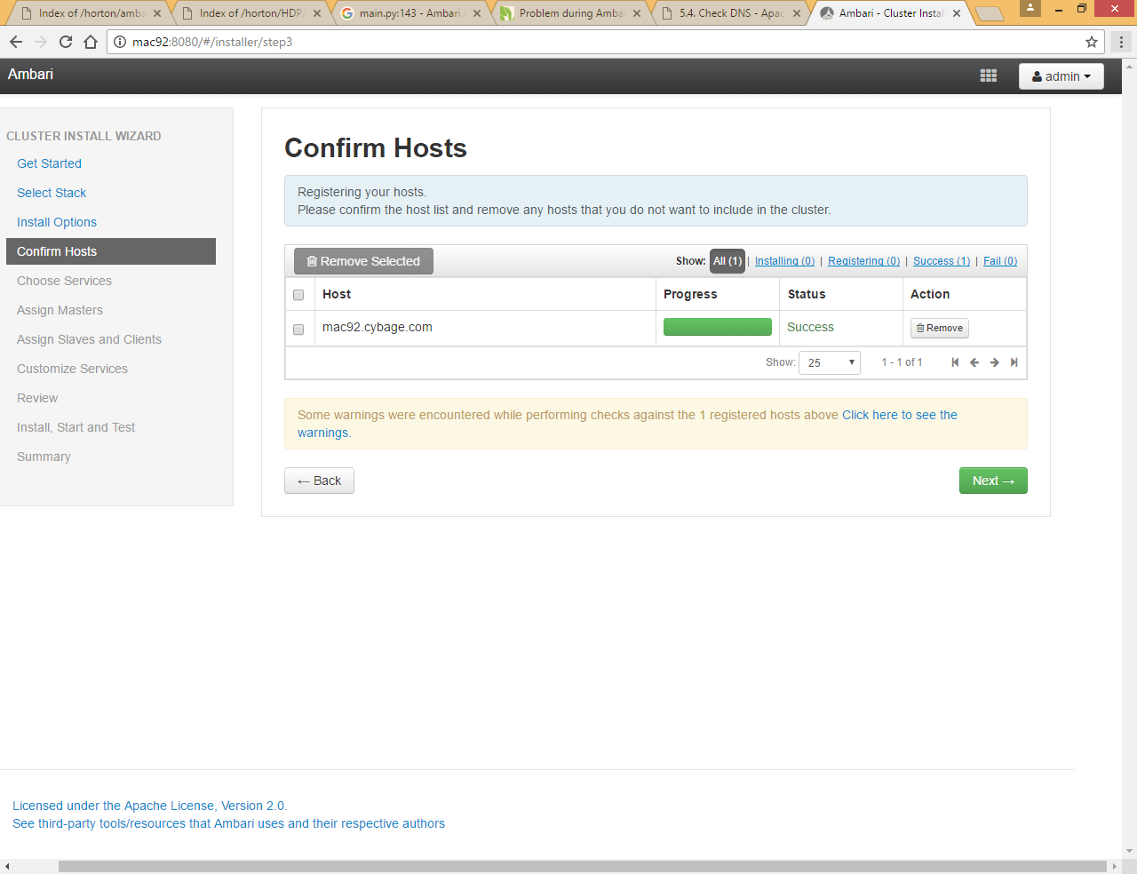

Now it is being installed successfully

You can check warning by clicking on **Click here to see the warnings** link

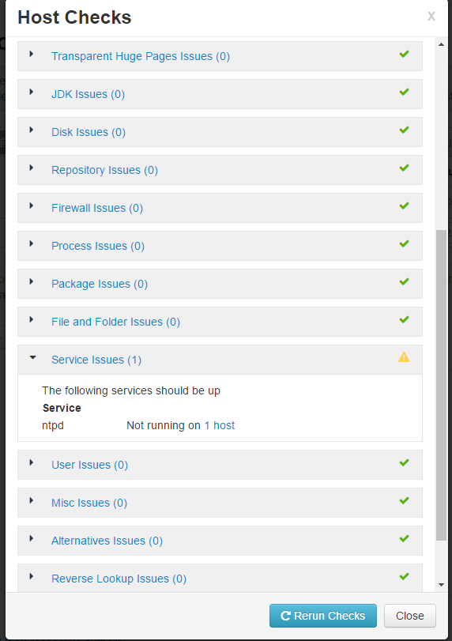

We can ignore this warning as we are installing on single not cluster in case of multi node cluster in production you need to install ntpd service so that all machine sync up with same time

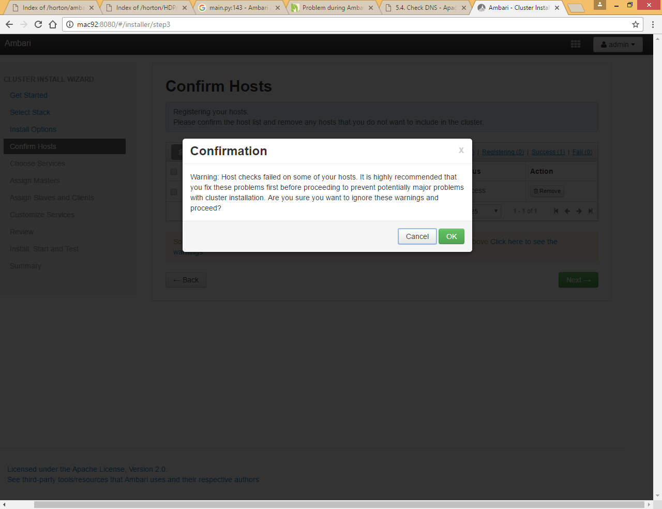

Click OK

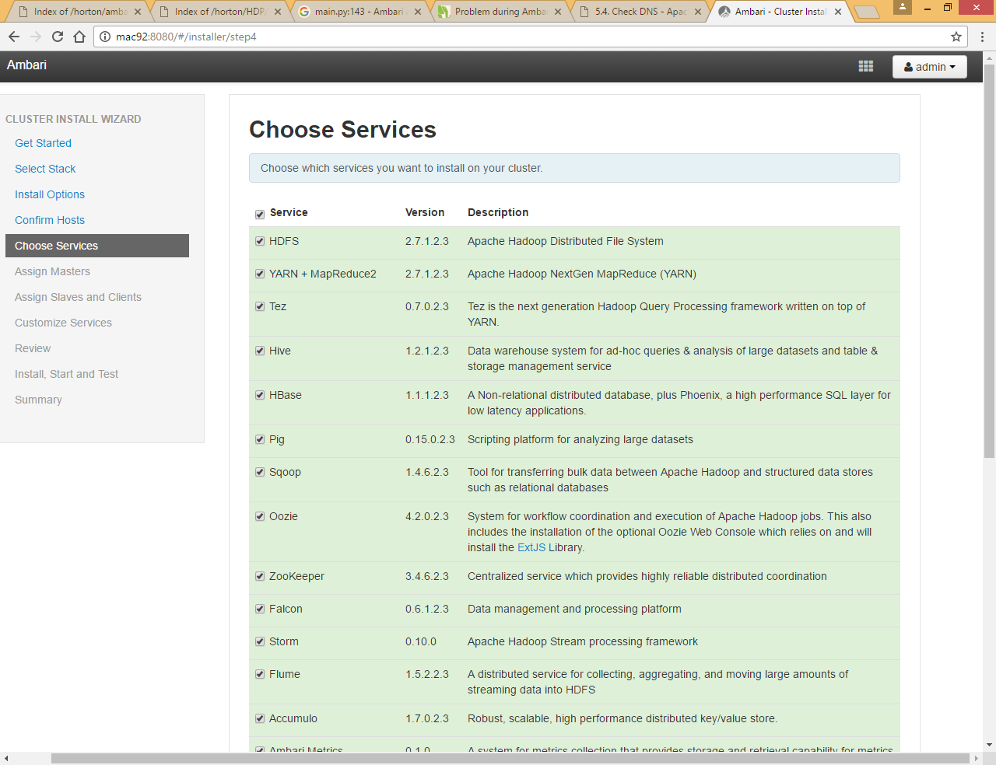

We will install service one by one

# Add Ambari Metric and Zookeeper Service

First we are going to install Ambari metric and zookeeper (zookeeper is required for Ambari metric so if we don’t select it, it will automatically select it in later stage) deselect all and just select Ambari metric and zookeeper

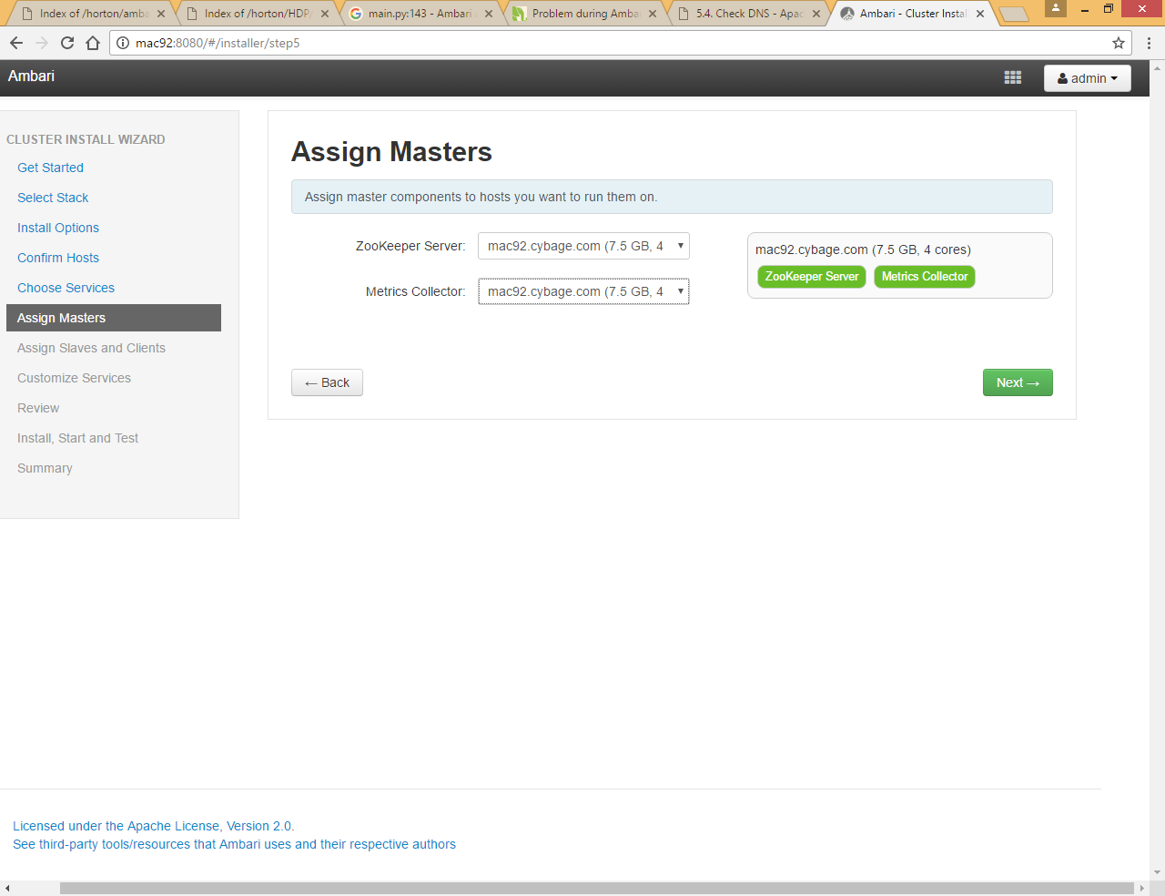

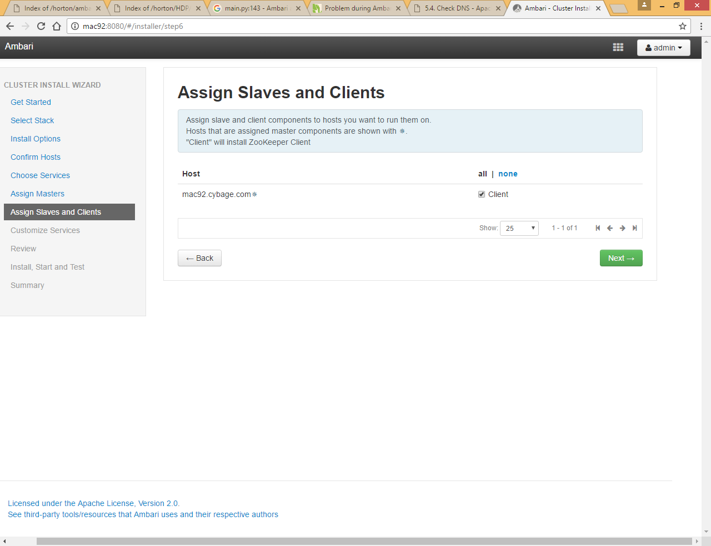

You can see all the configuration parameter here for zookeeper and Ambari metric

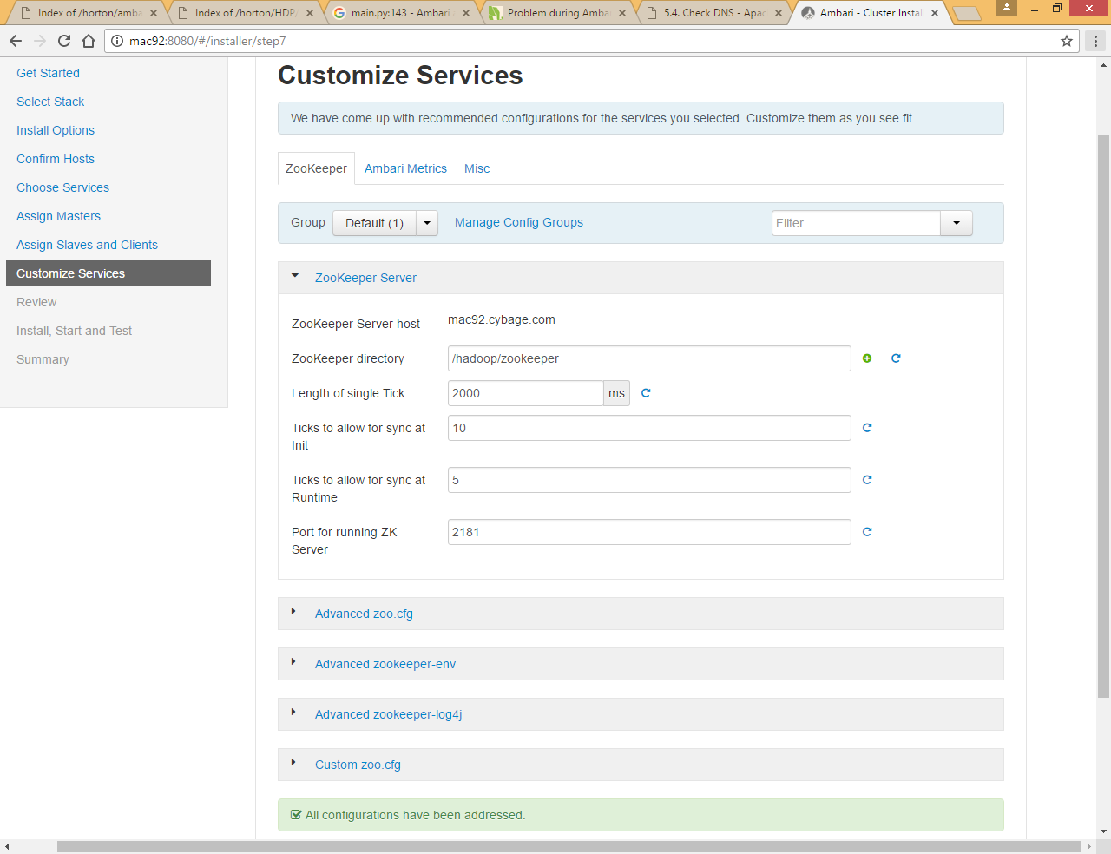

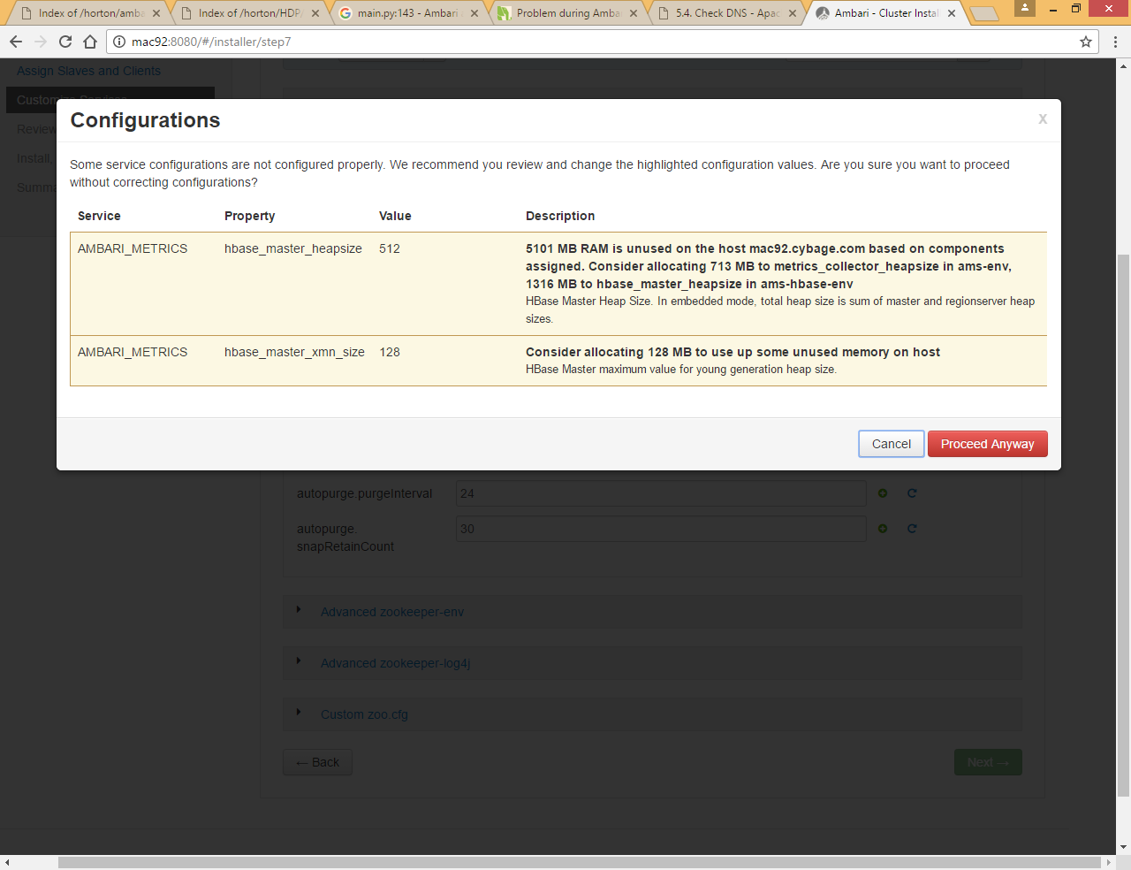

Click on Proceed Anway

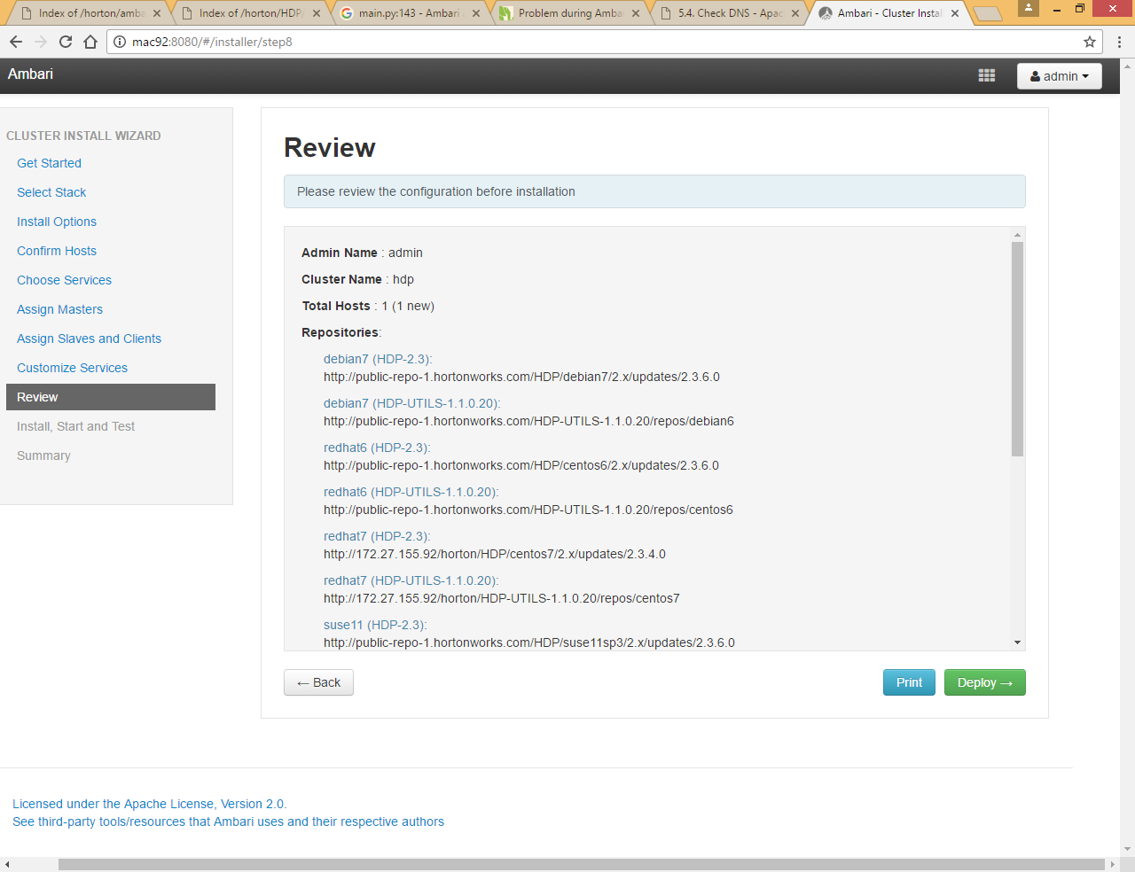

Click Deploy

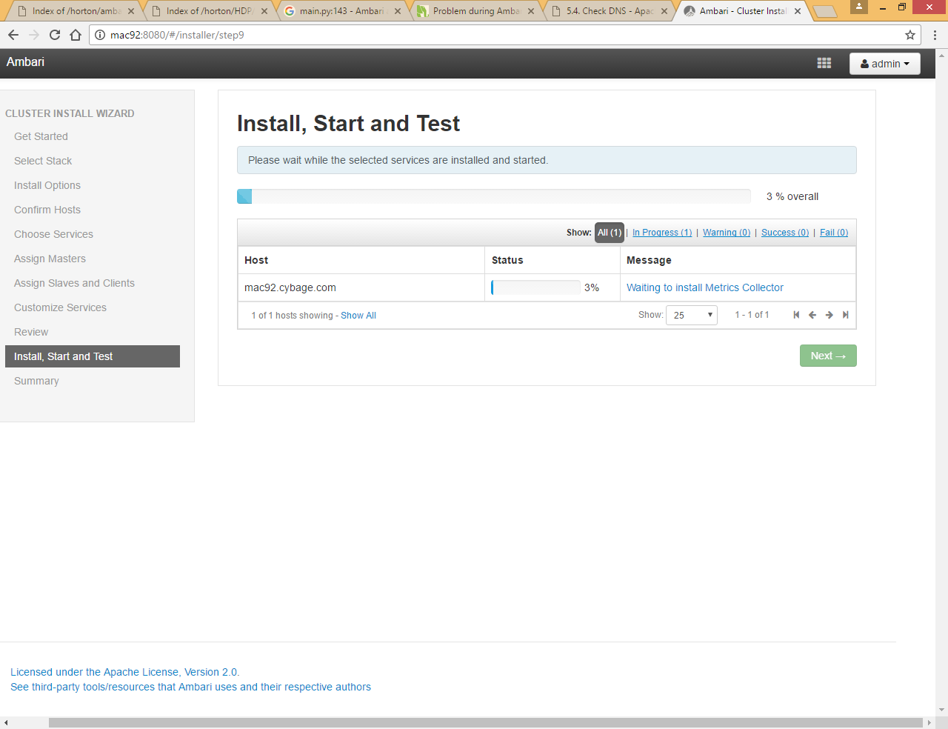

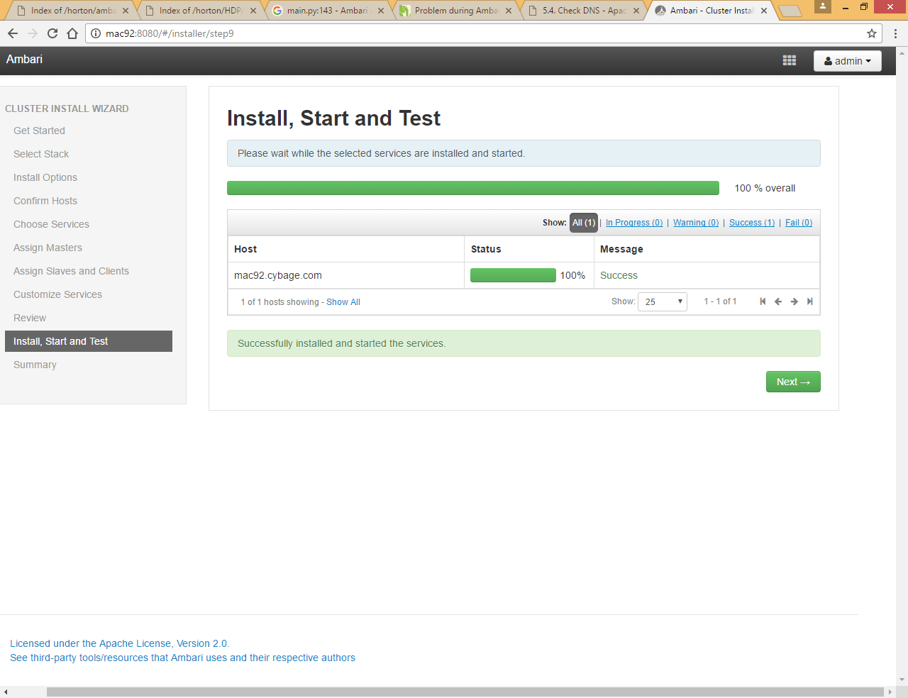

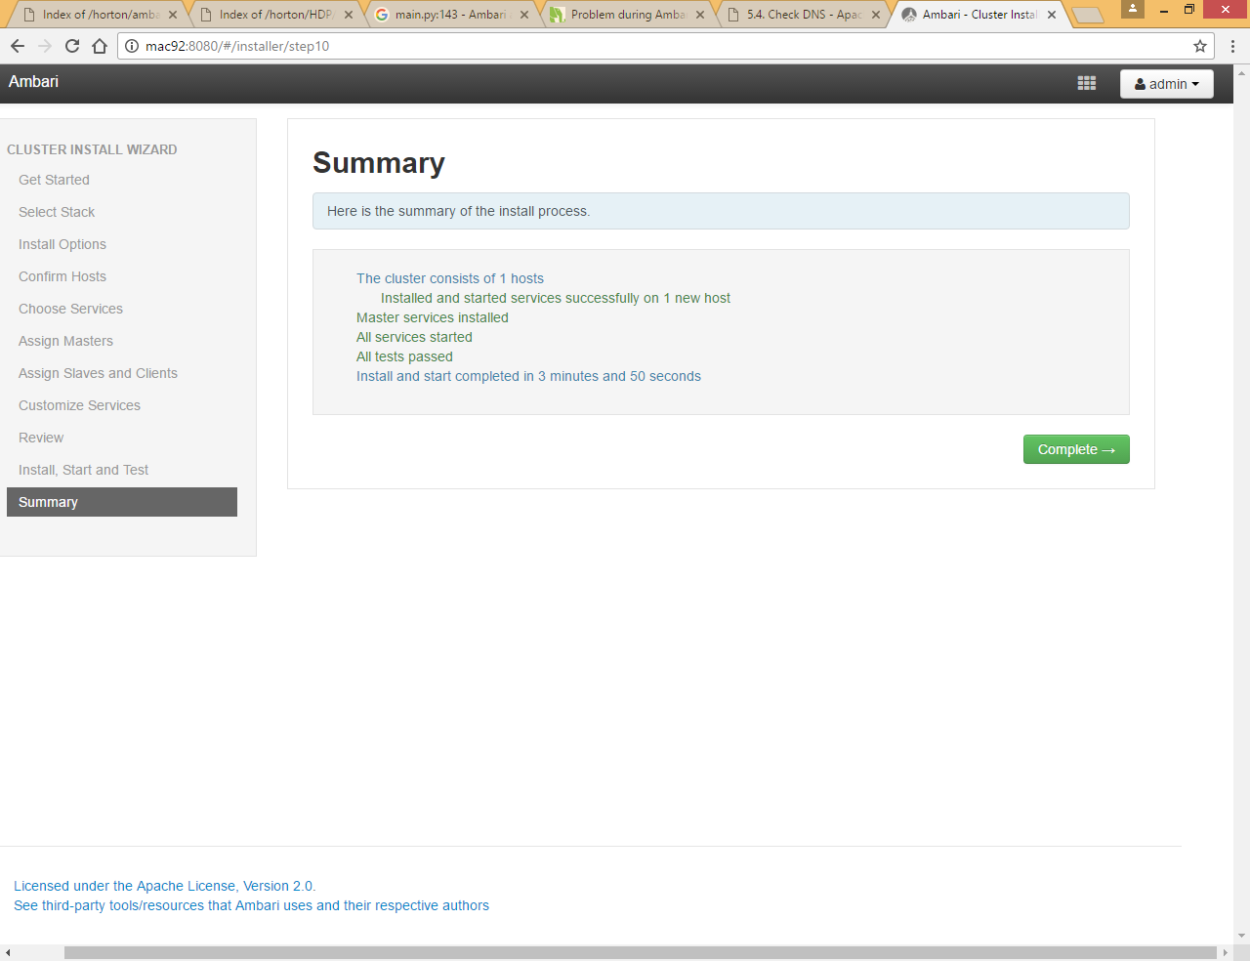

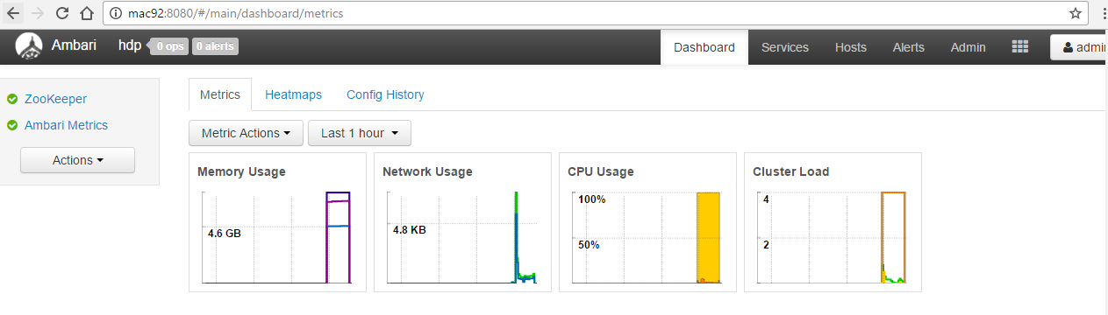

# Add HDFS Service

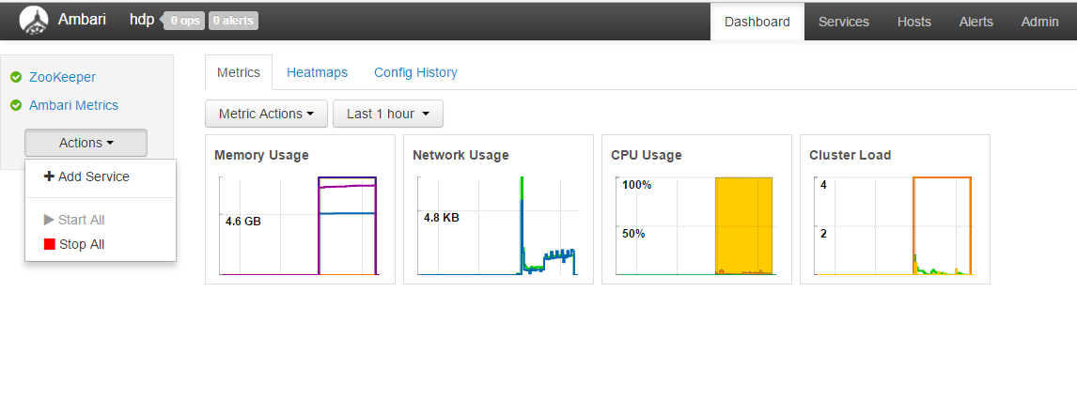

Click on Add Service

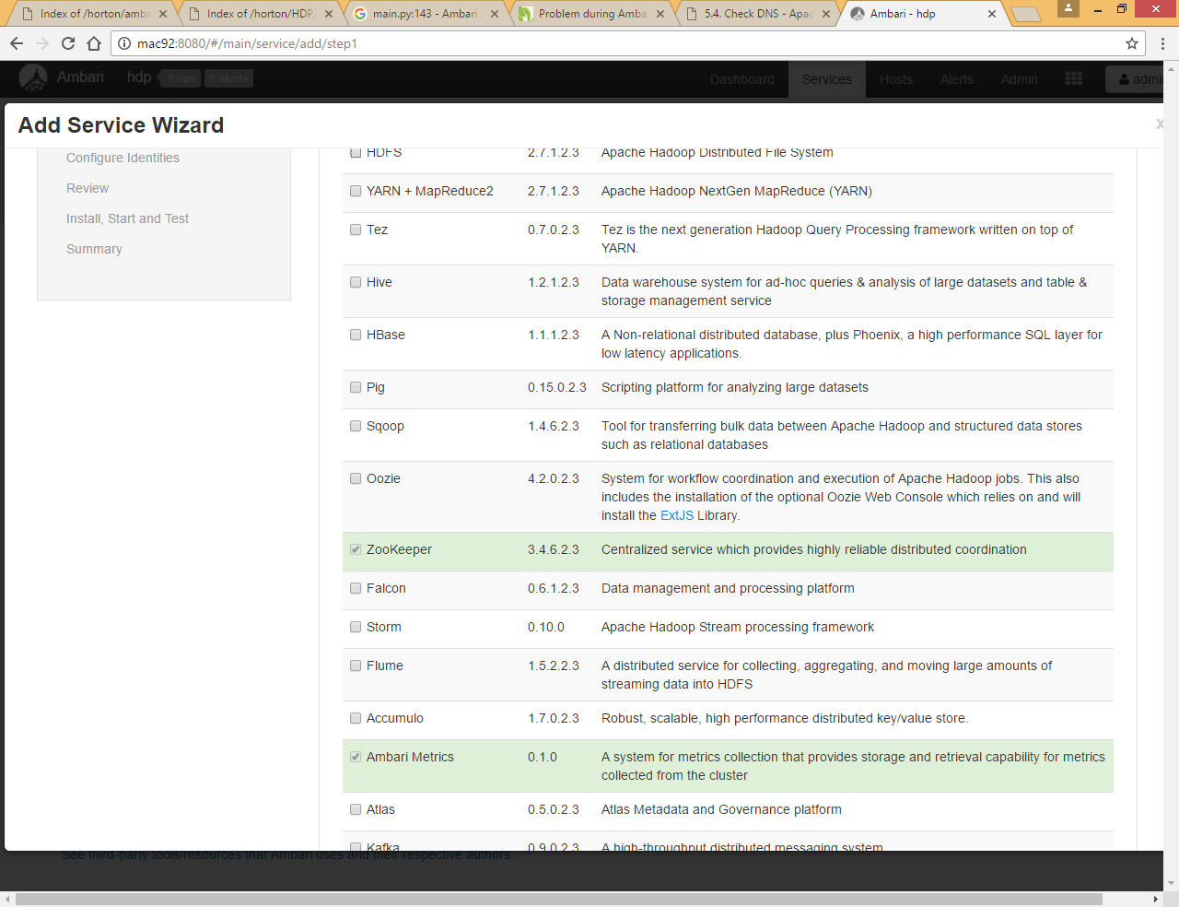

Zookeeper and Ambari Metrics are already selected as we already installed these services

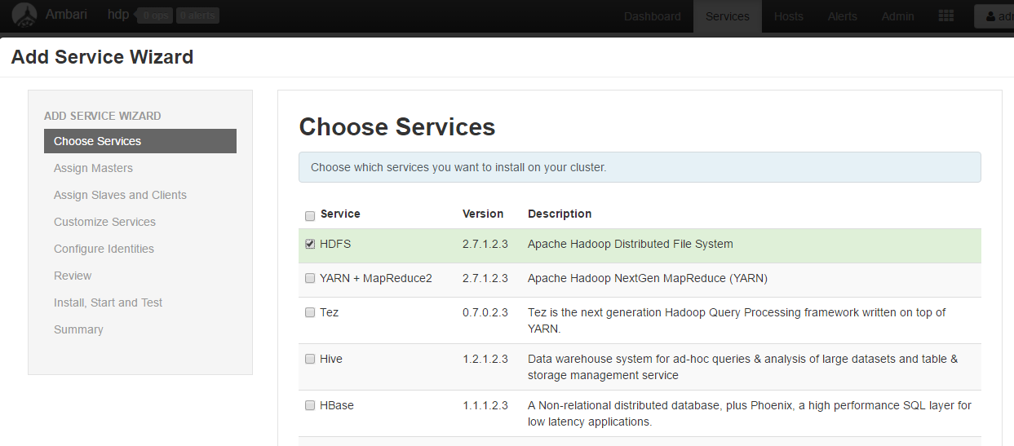

Select HDFS and click Next

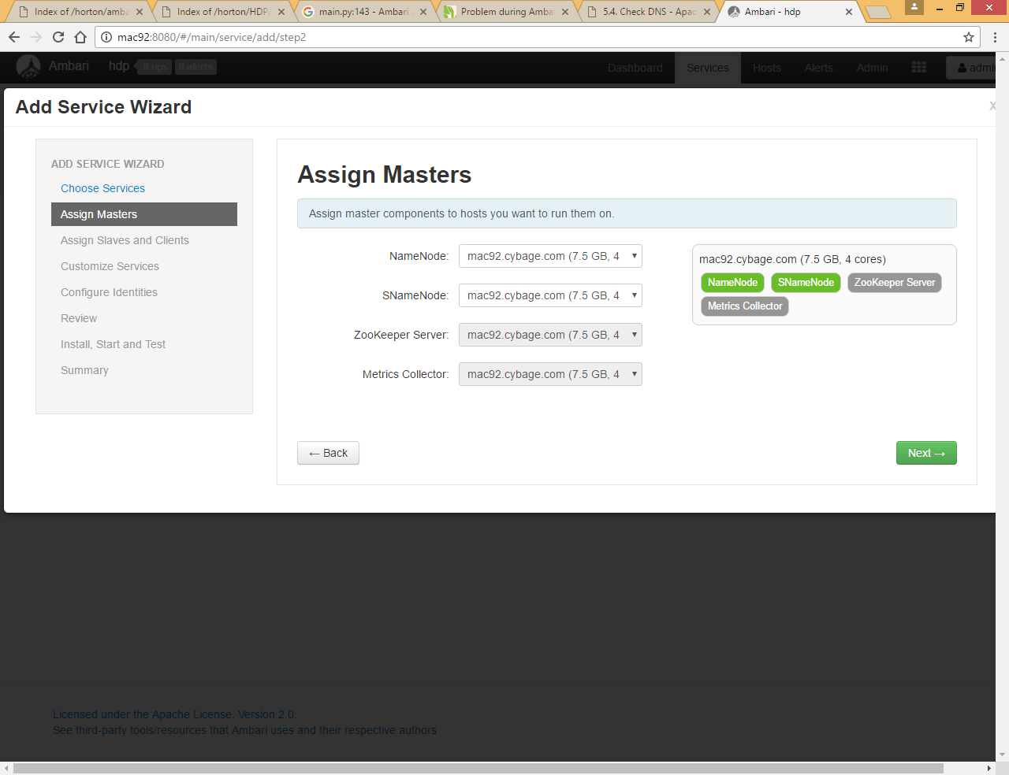

Since this is just one node cluster so we cannot configure different nodes

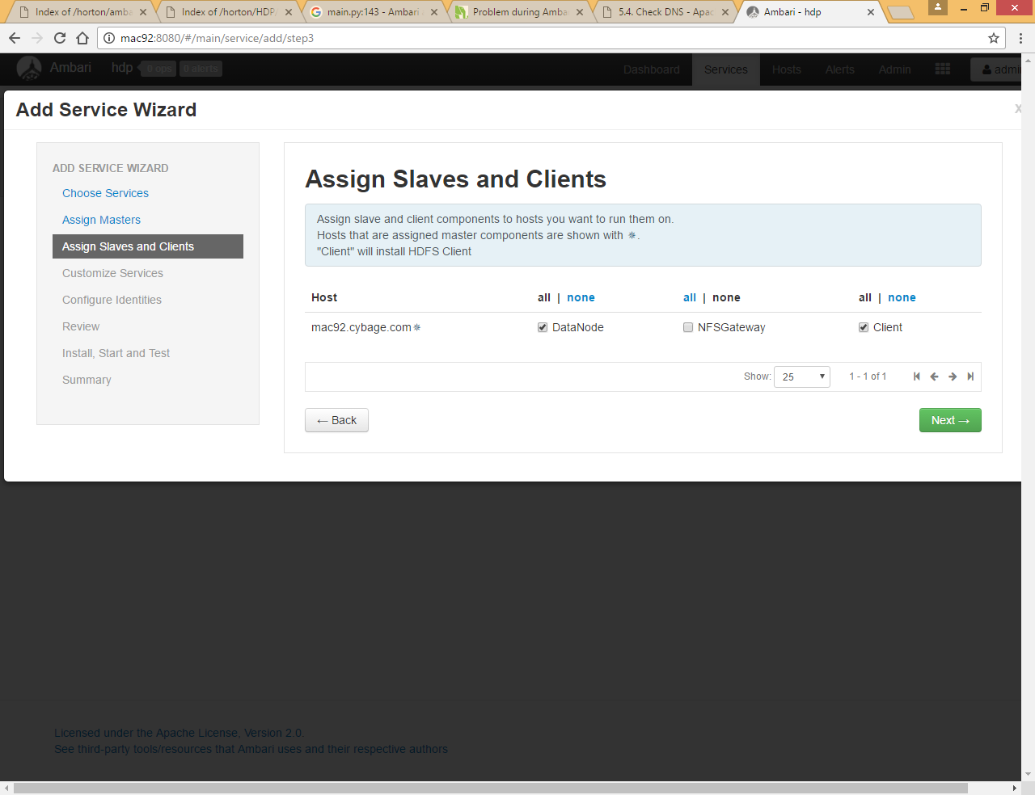

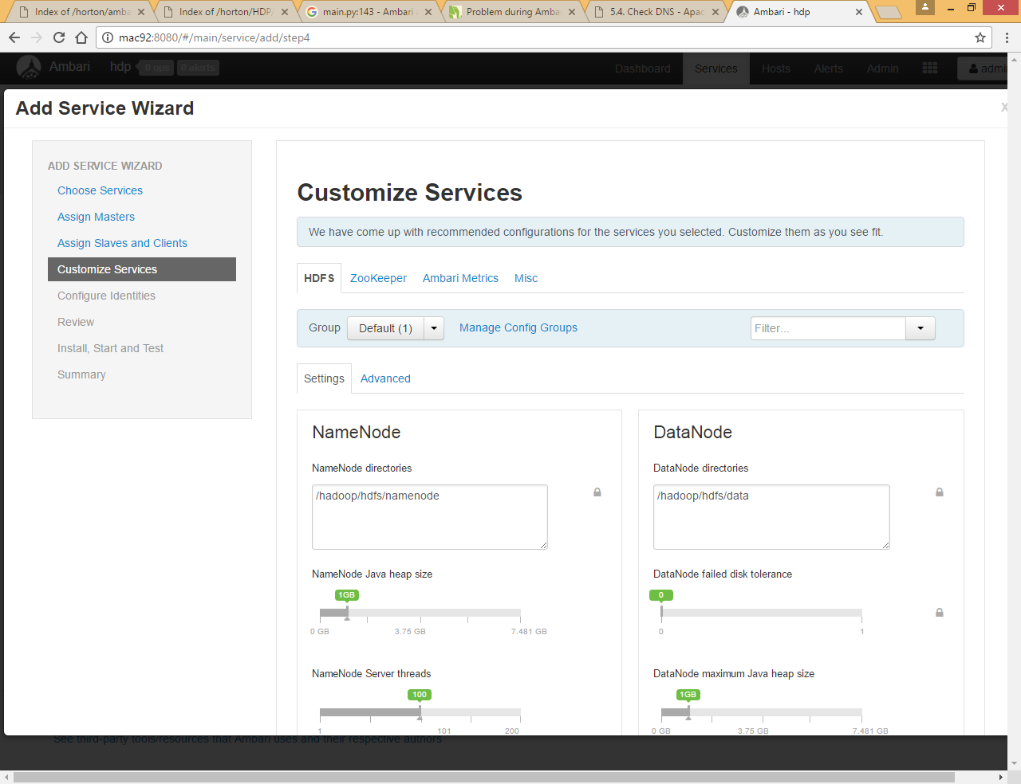

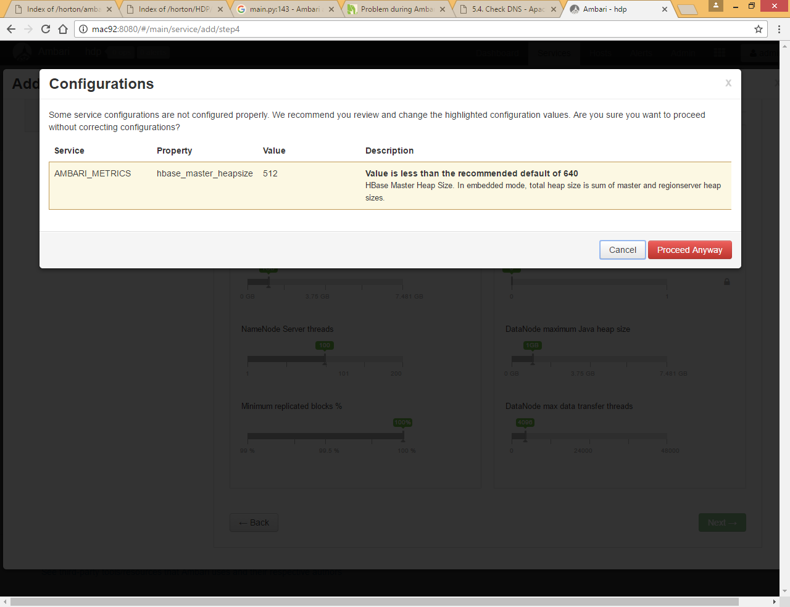

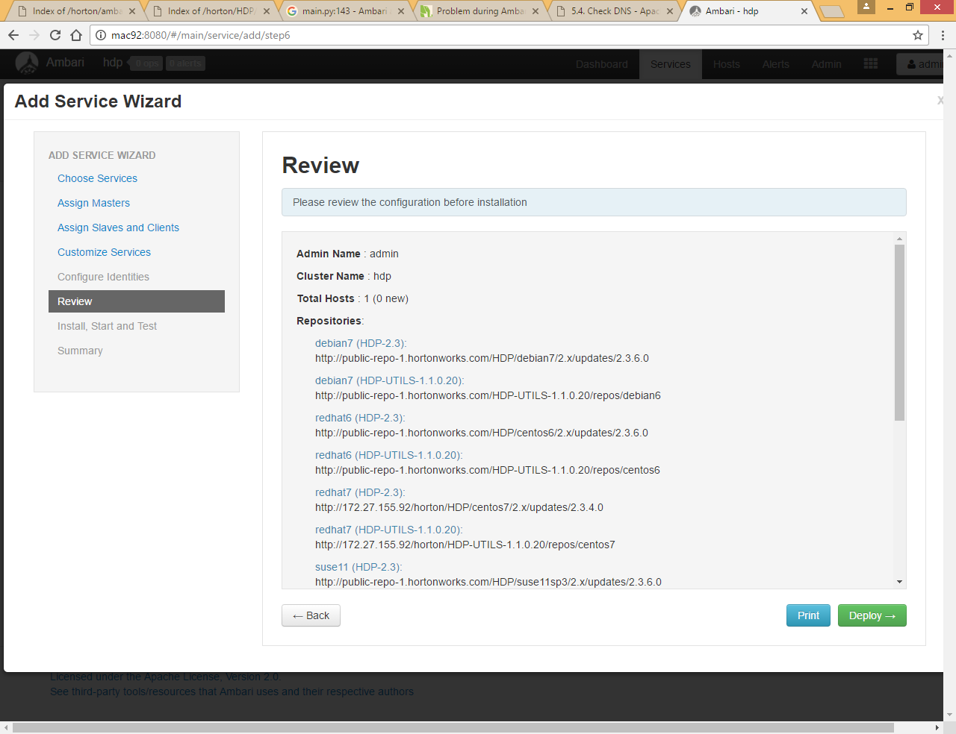

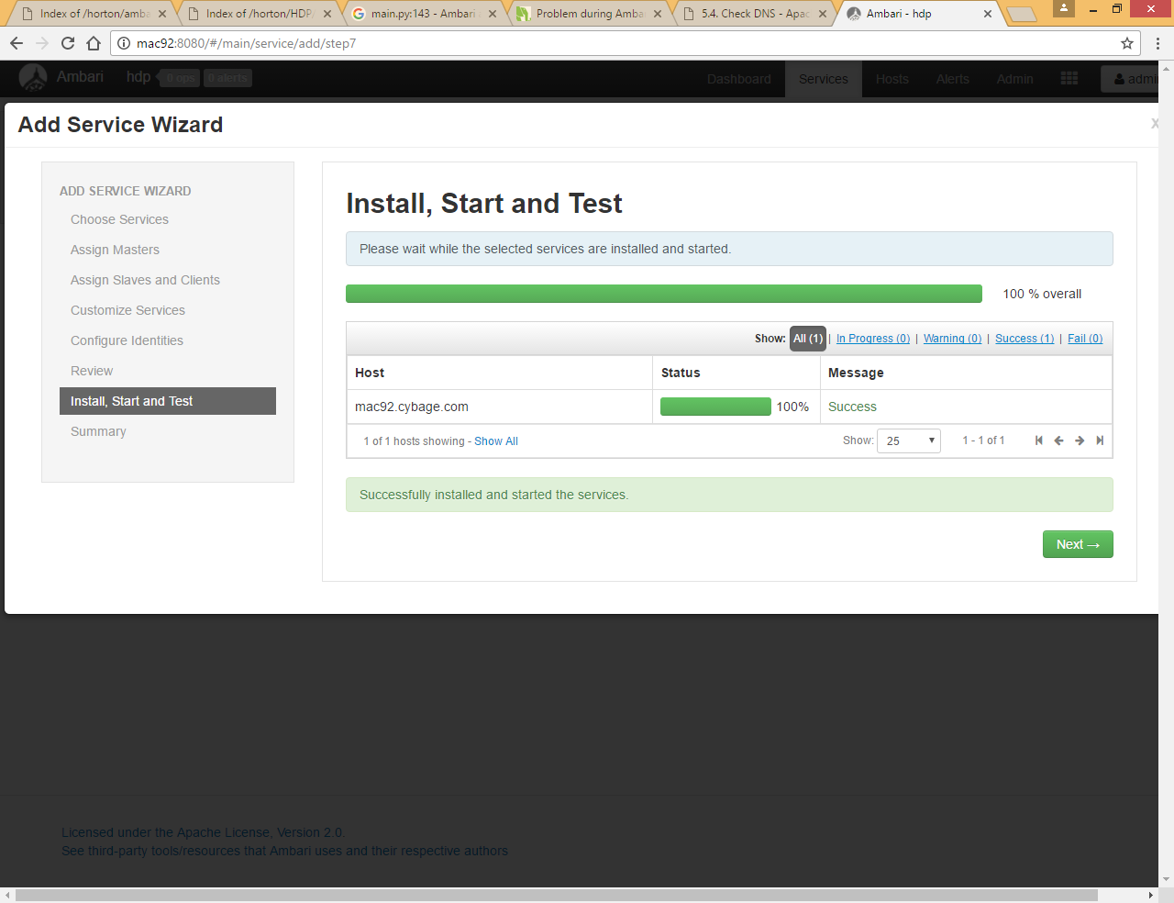

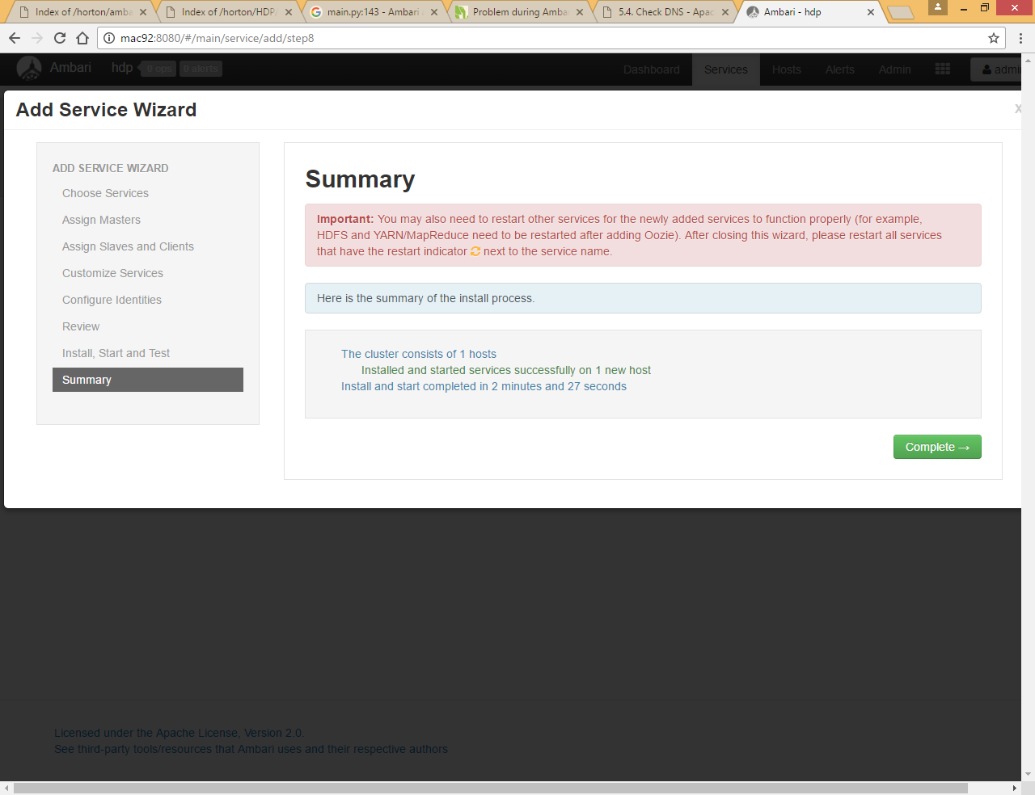

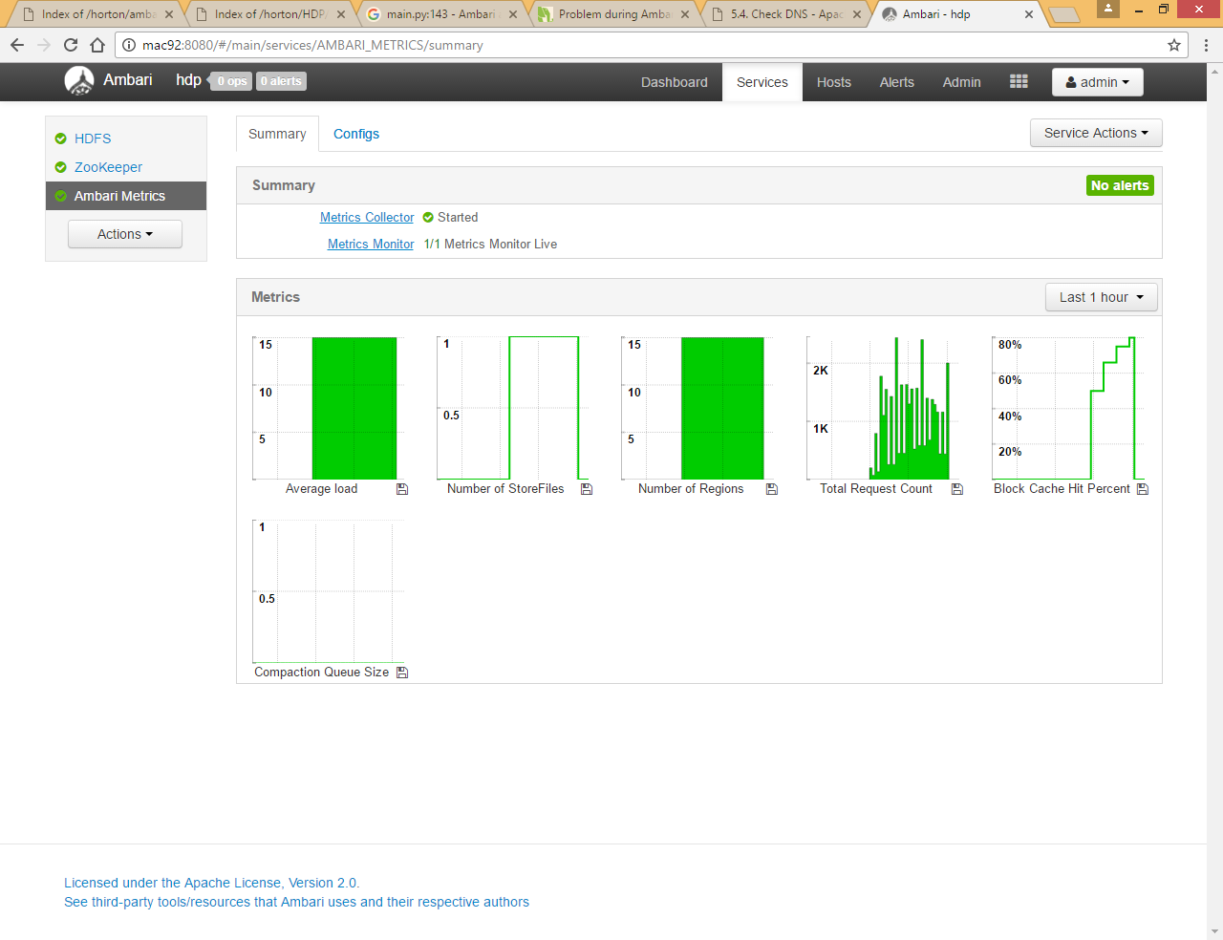

Now you can check the file system and check if namenode, datanode and secondary name node edit directories created

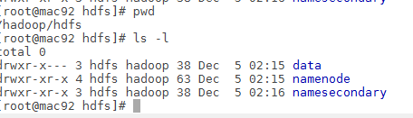

Now you can check if hdfs dfs command is working

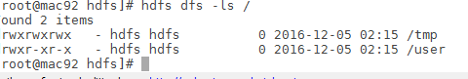

# Add Yarn Service

Action -> Add service

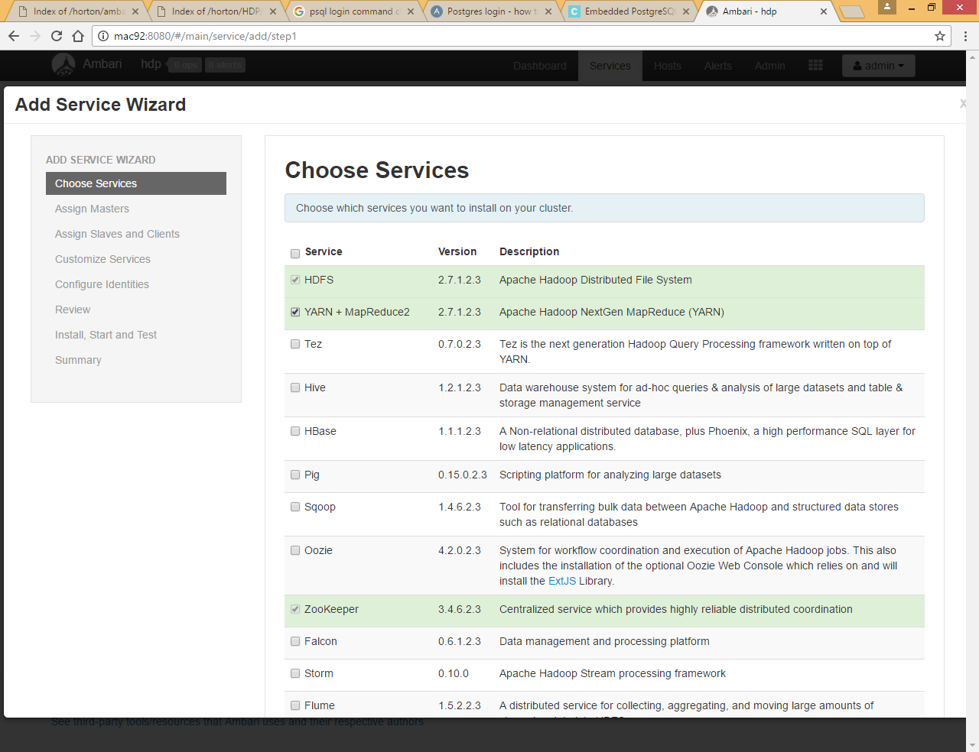

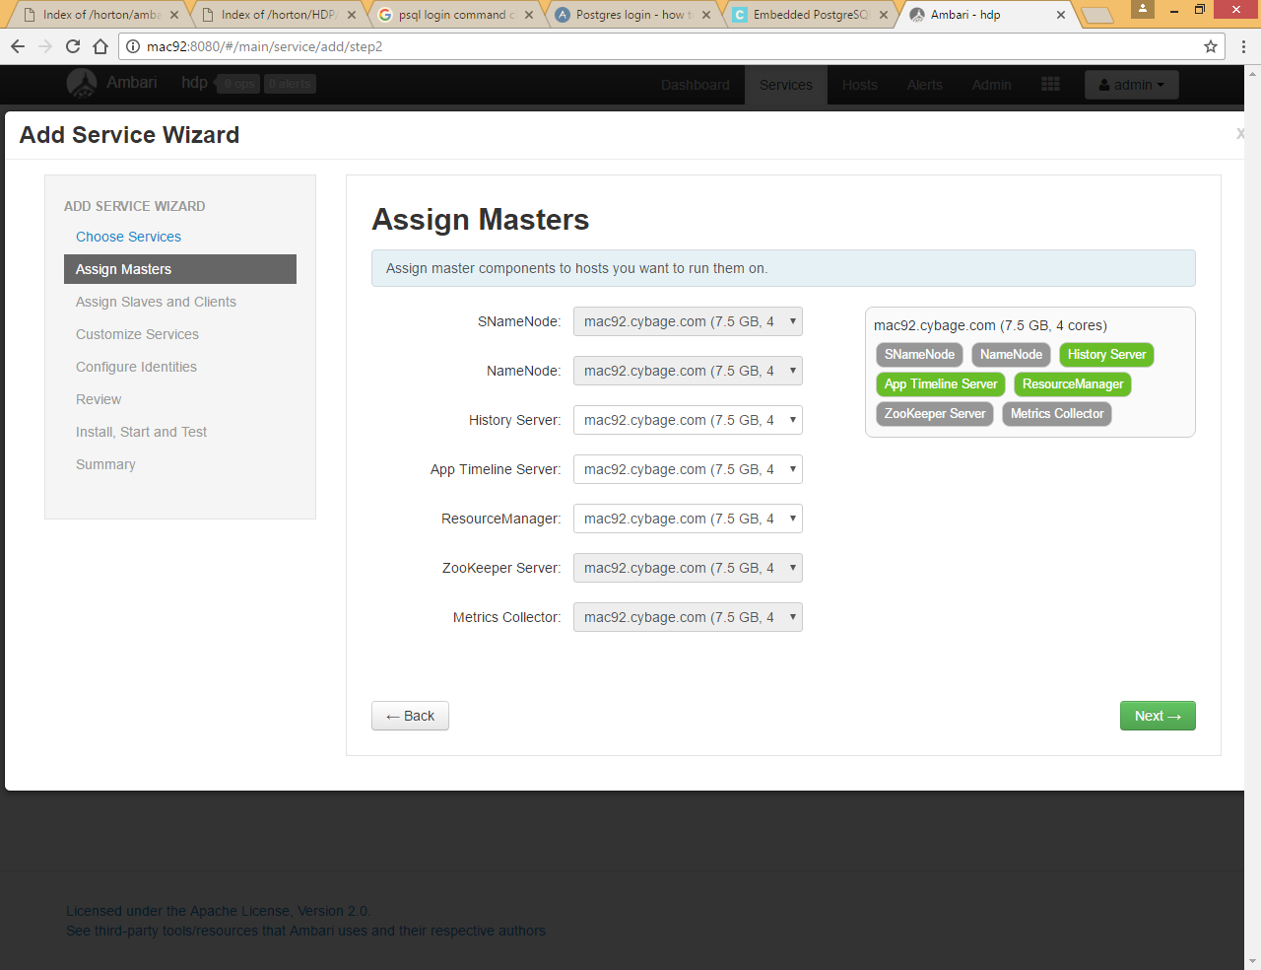

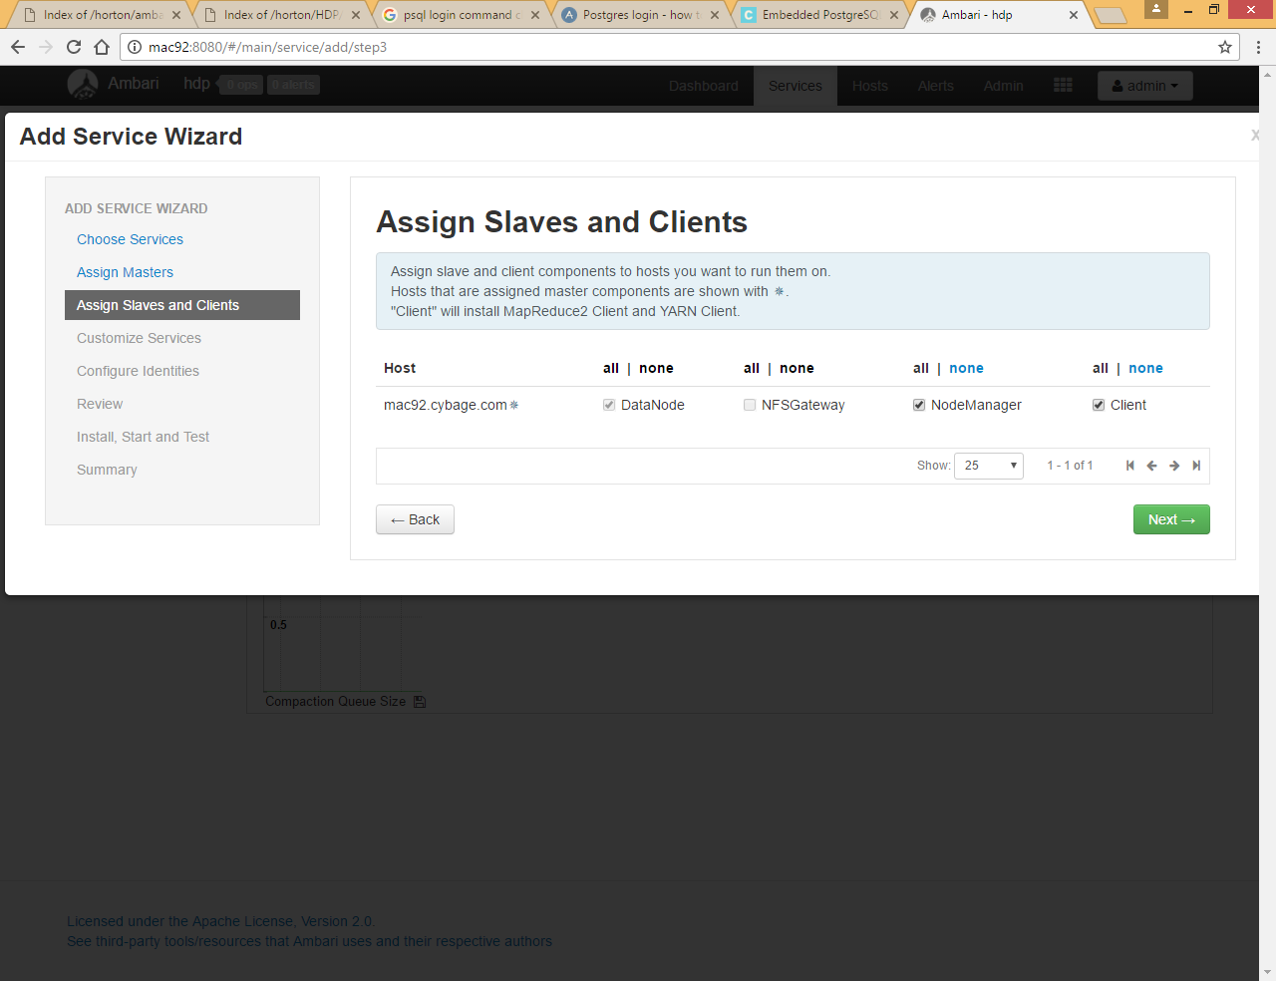

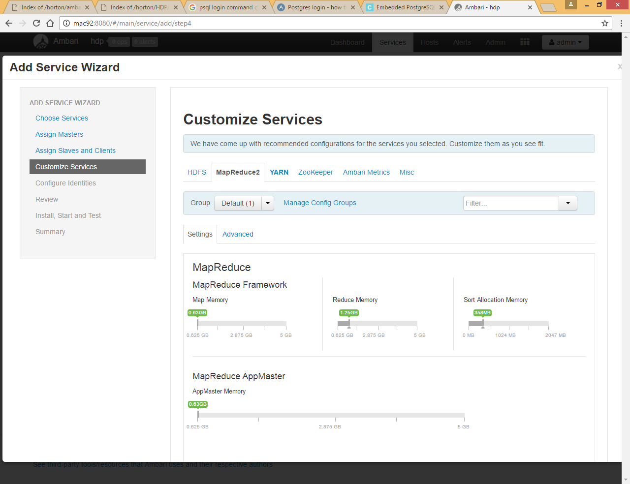

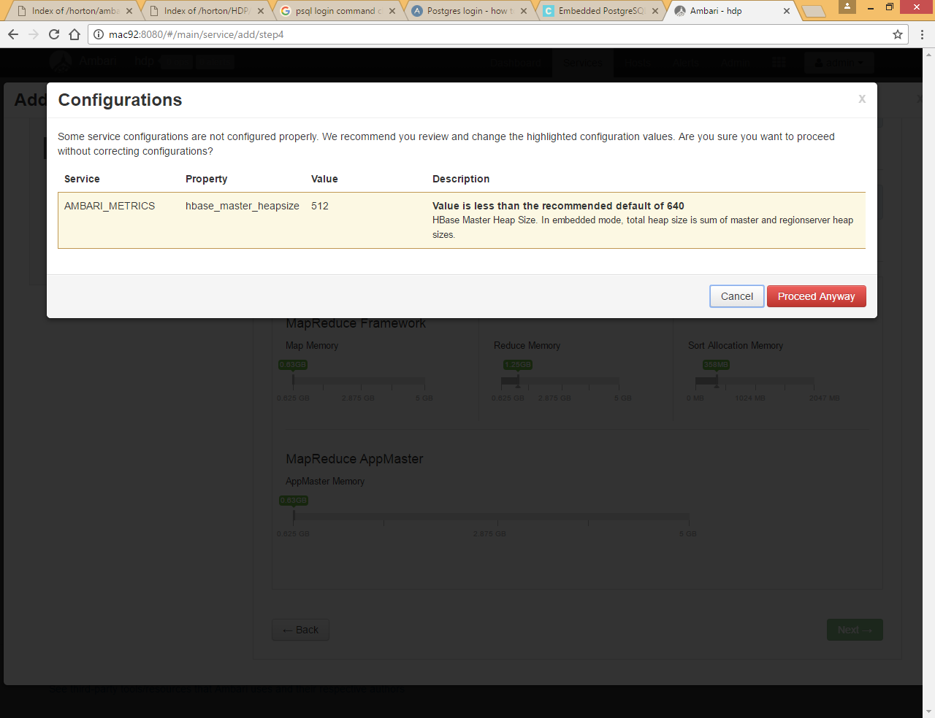

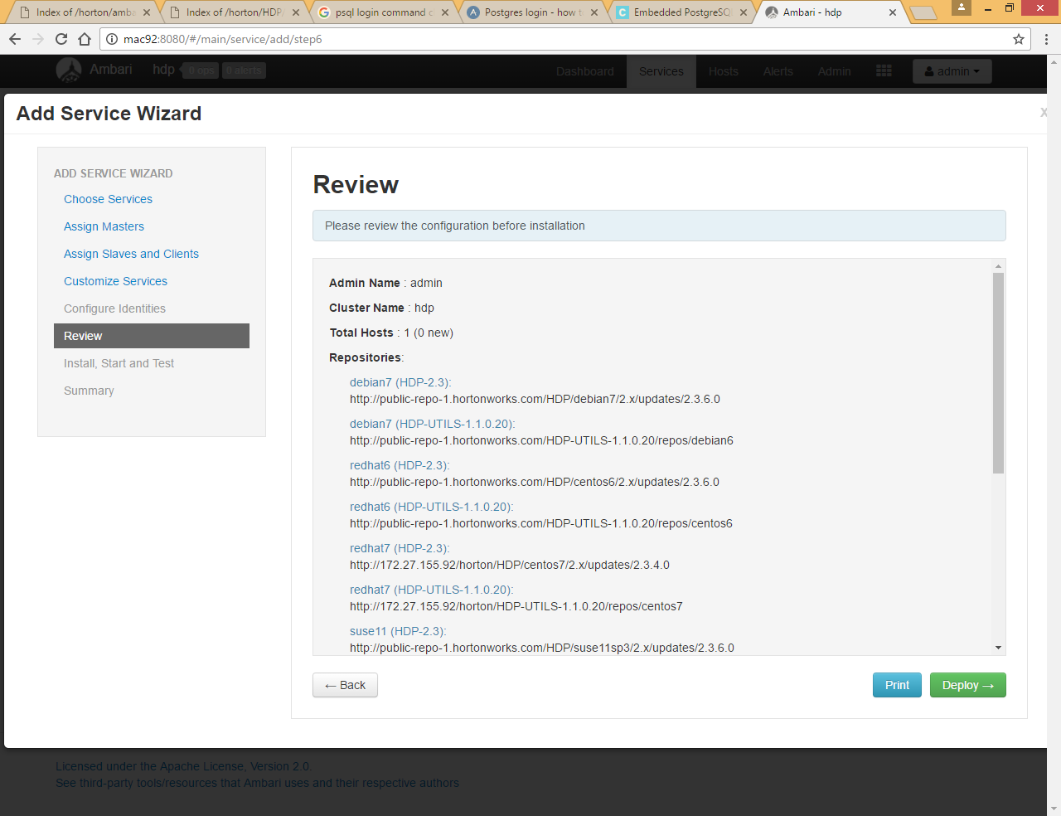

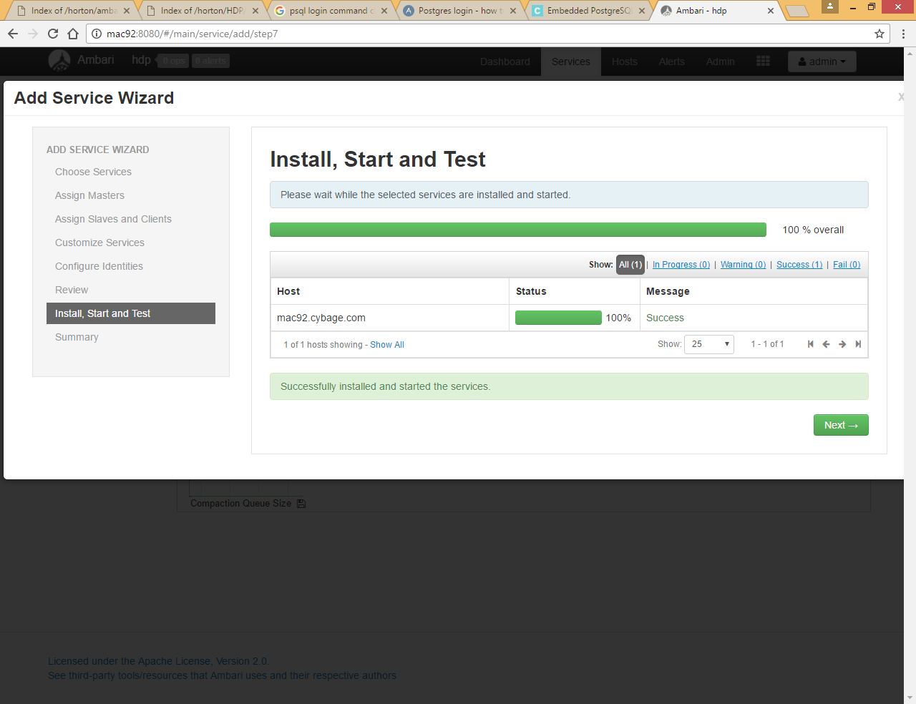

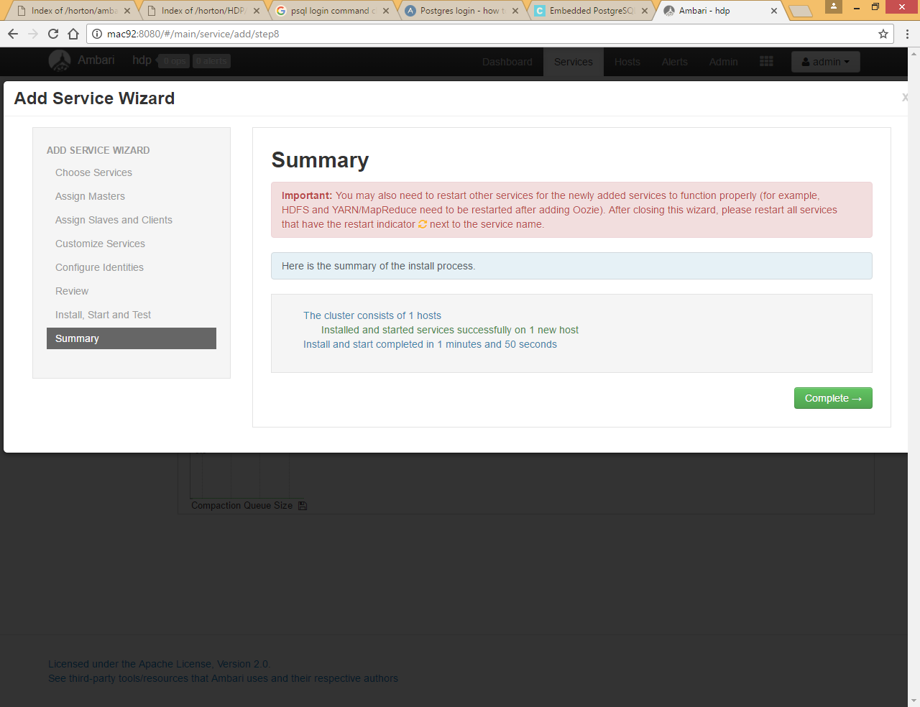

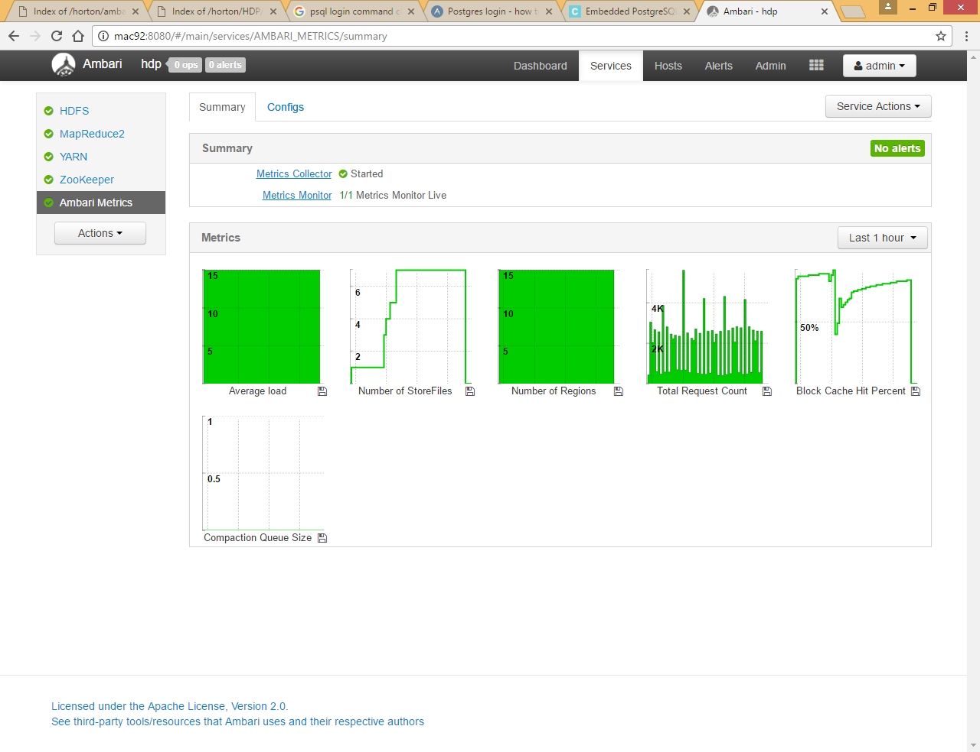

# Add Tez Service

Tez is not a map reduce tool but it uses YARN behind the scenes and it will try to execute map reduce based program like hive queries and pig scripts in its own way

Tez is an application framework on top of YARN to allow complex directed acyclic graph (DAG) to process data

Tez can be used to run Apache Hive queries as well as Apache Pig Latin scripts. Hive queries or Pig scripts will be run as Tez jobs

Tez comes out of the box with Hortonworks, but not with other vendors like Cloudera

It is client only tool, as it uses YARN but not Map Reduce to process the data

It tries to fine tune Hive or Pig queries which spawn into multiple jobs by eliminating HDFS between dependent maps reduce jobs

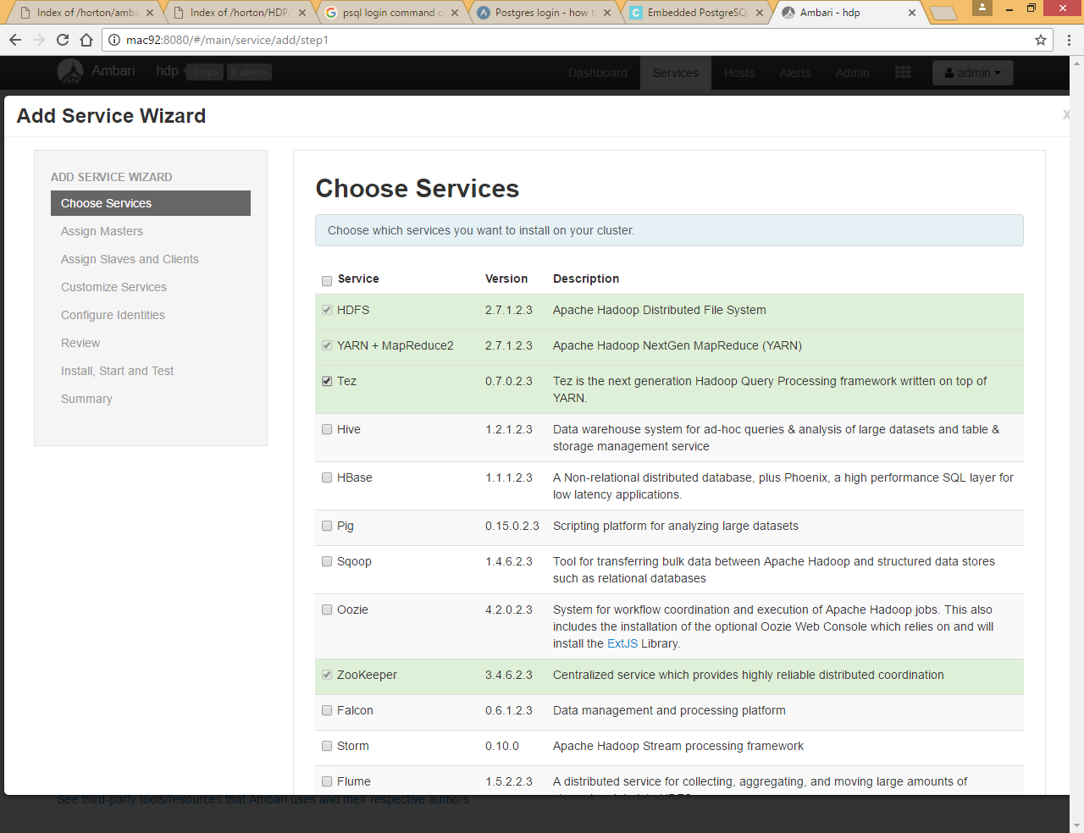

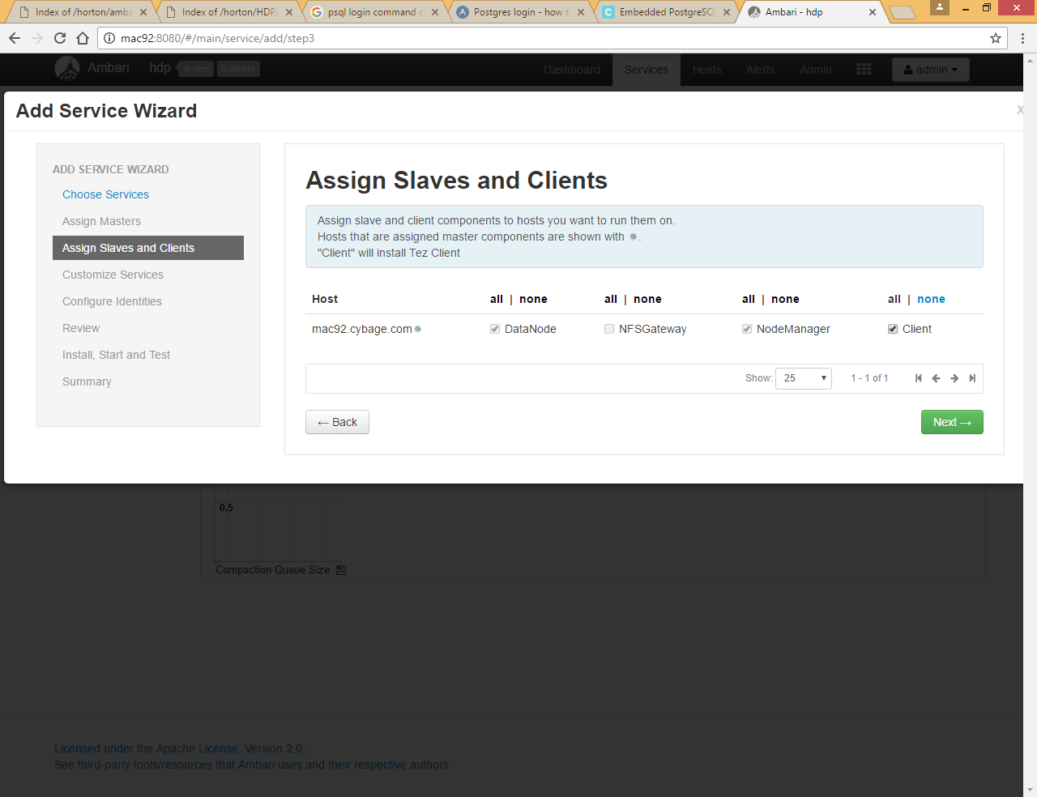

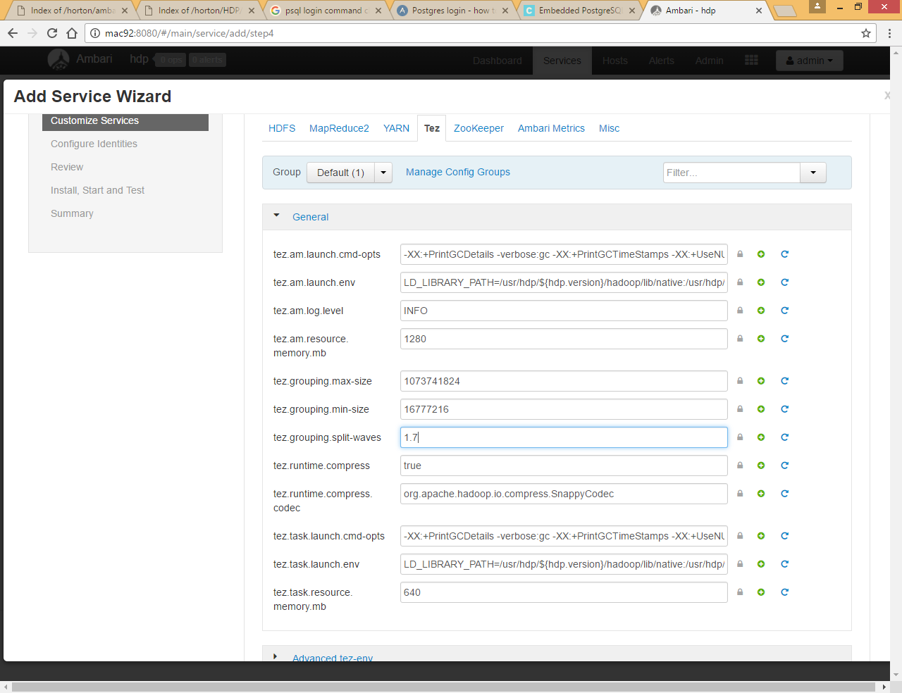

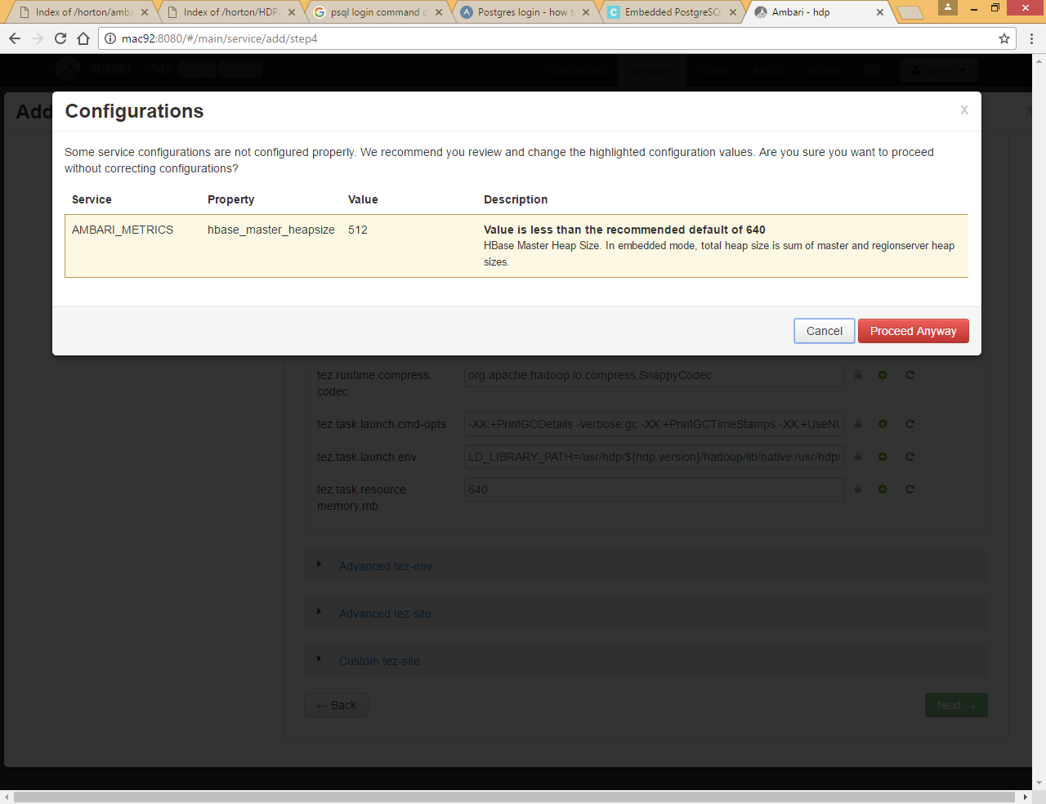

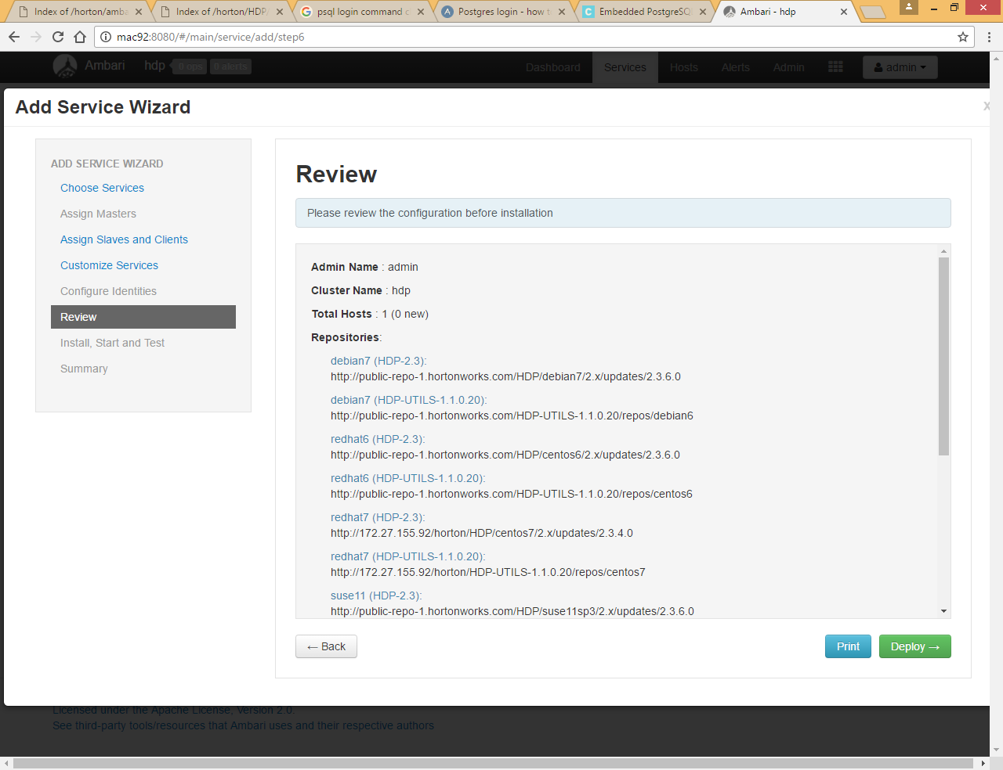

You can see that it is installing using local yum repository for redhat7

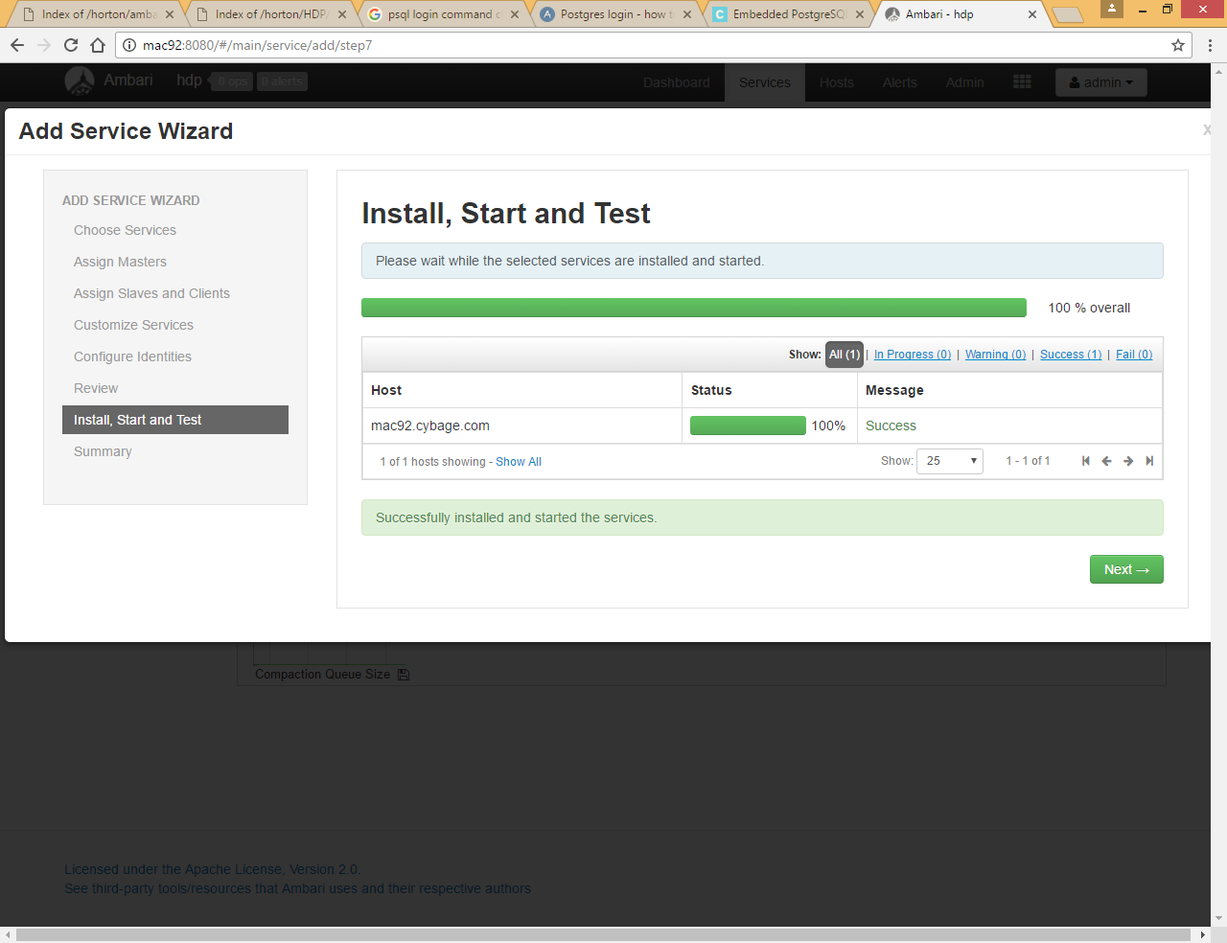

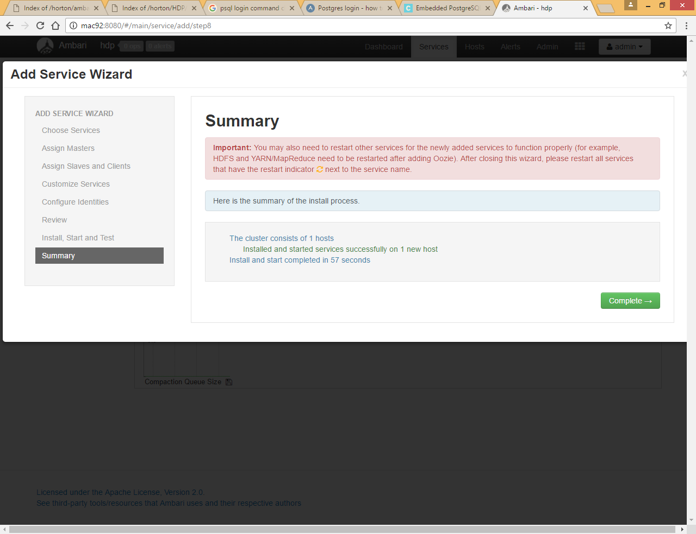

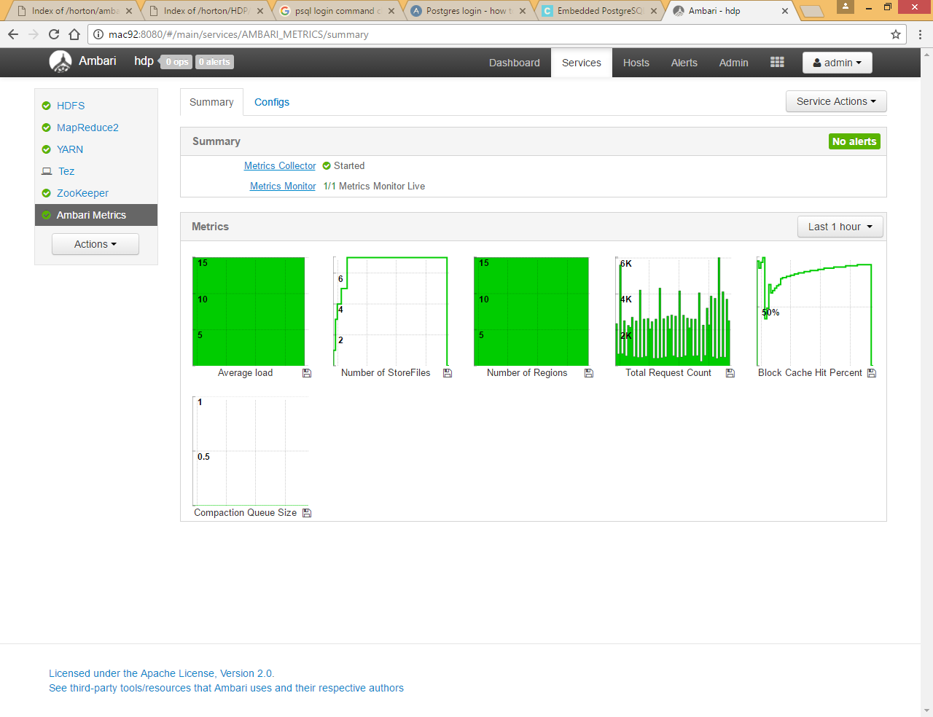

You can check tez config file placed under /etc/tez/conf

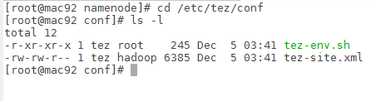

# Add Hive Service

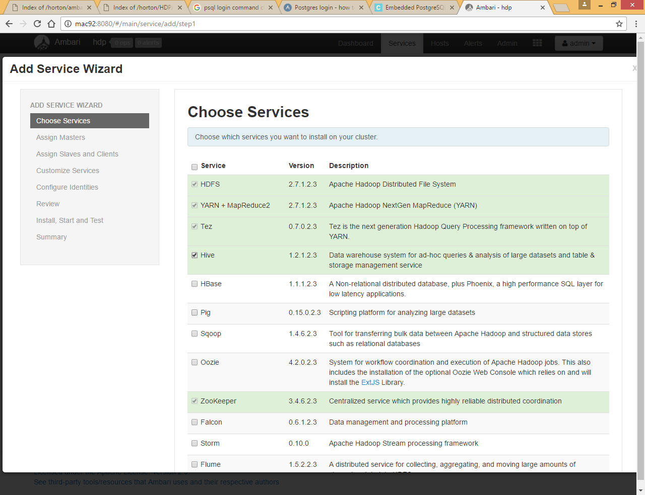

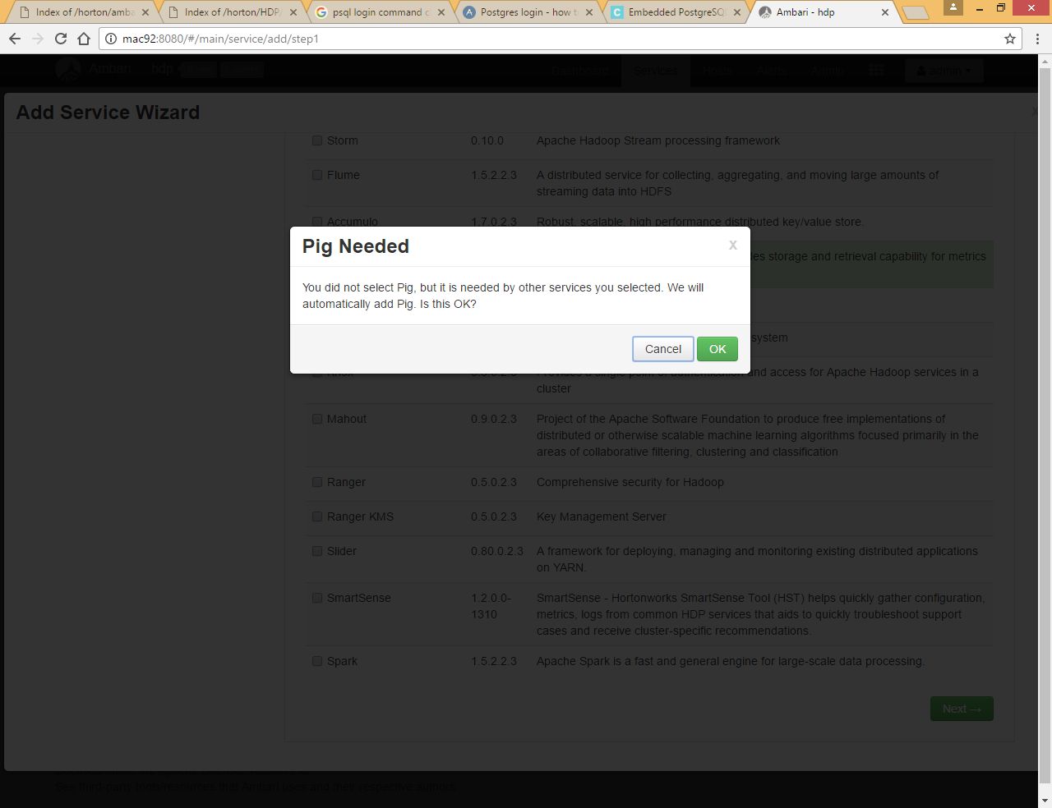

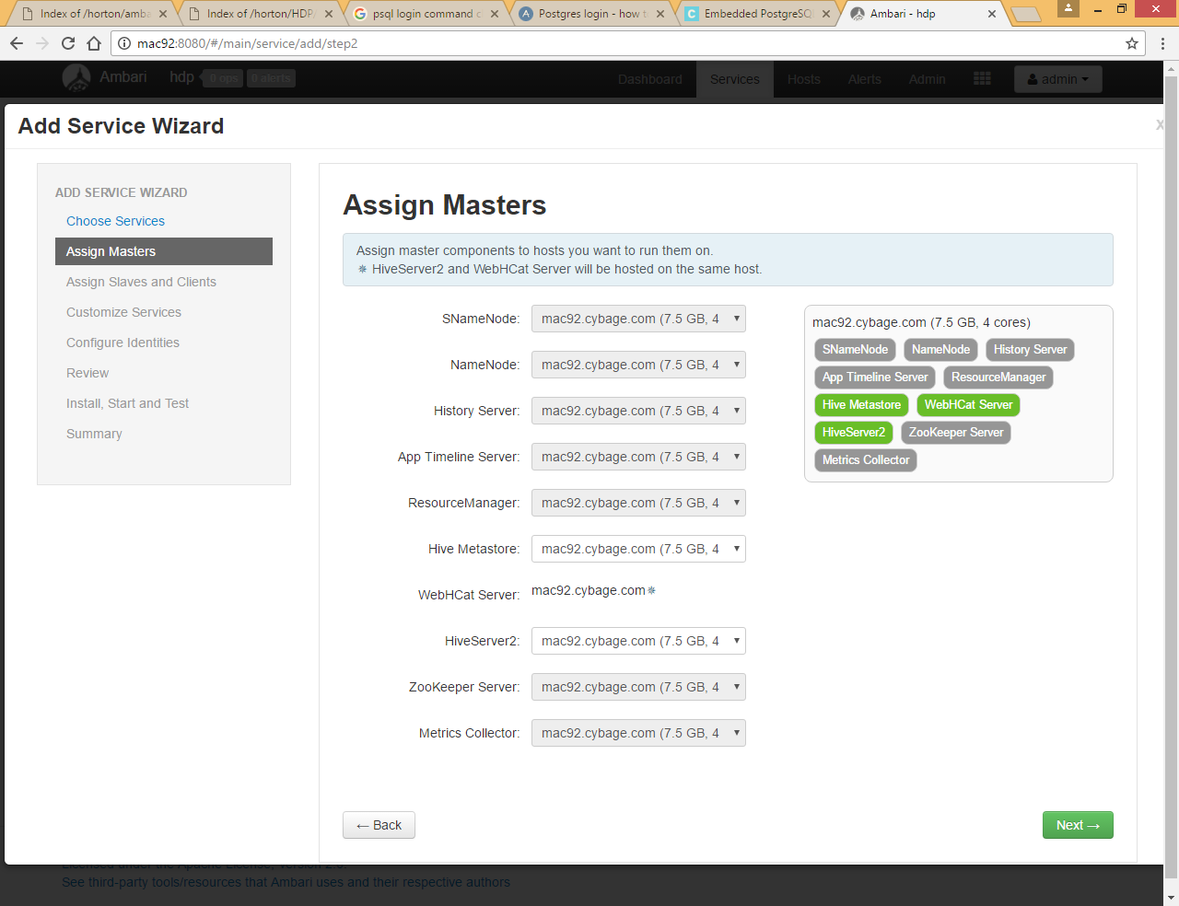

It requires meta store to store metadata and hiveserver2 will be used to connect to hive using jdbc

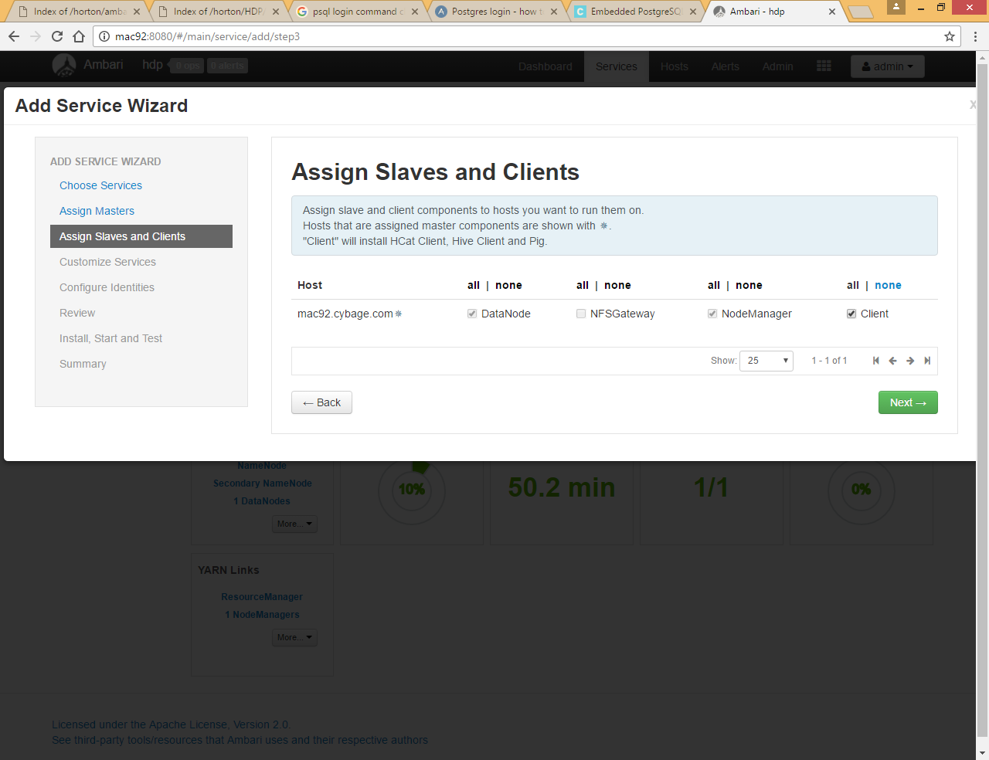

Here we already setup the my sql server by using attached document



We can use option 2 (if you haven’t installed mysql server than you can choose option1)

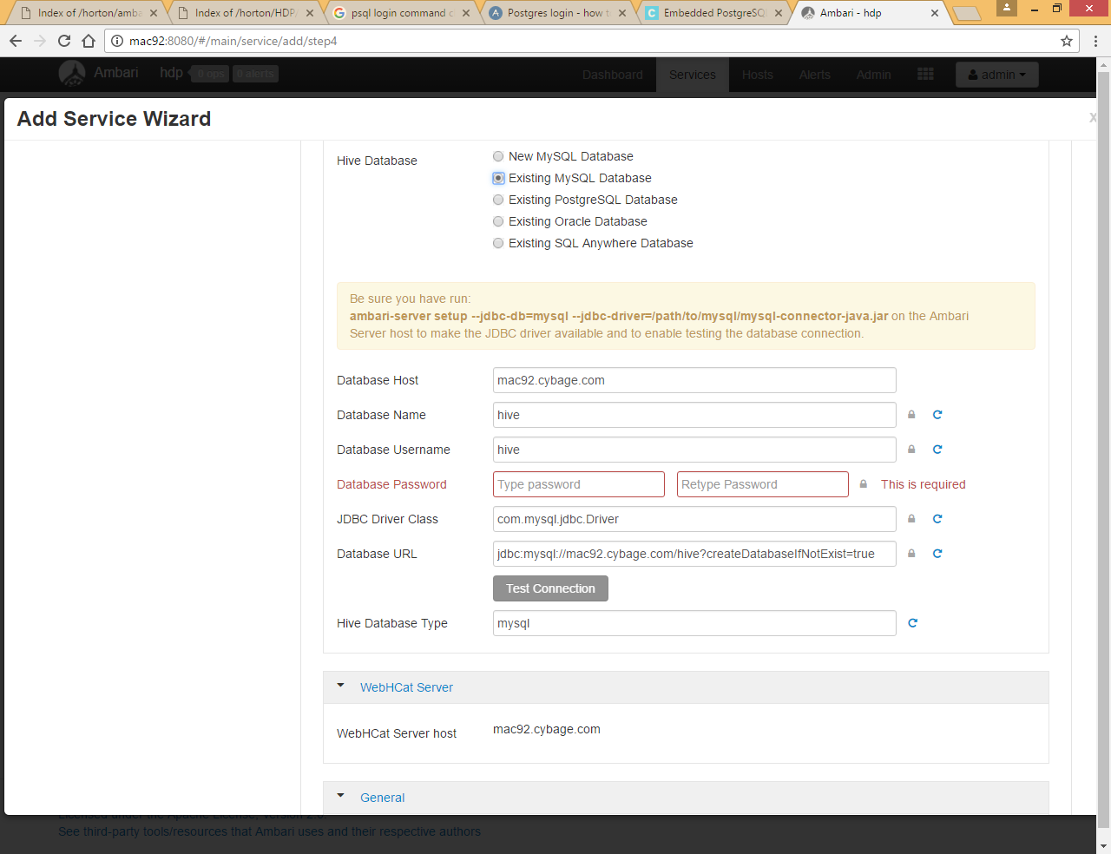

Fill all values and click Test Connection

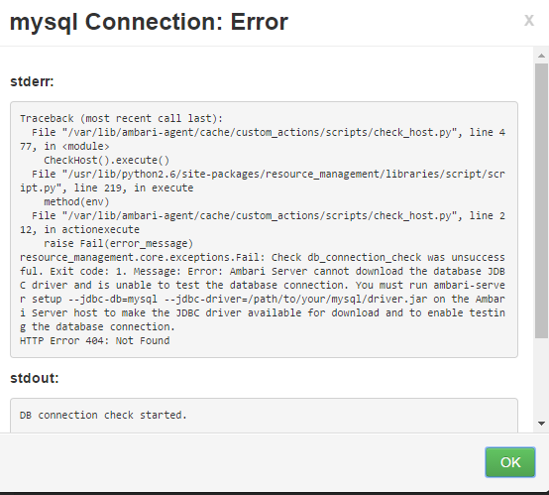

We already placed the mysql-connector jar inside /usr/share/java folder so we need to run below command

|  |
| --- |
| ambari-server setup --jdbc-db=mysql --jdbc-driver=/usr/share/java/mysql-connector-java.jar |

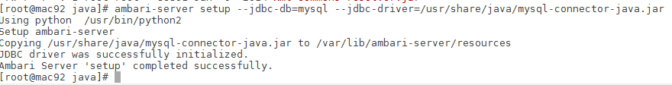

We need to have mysql-connector-java.jar files under /var/lib/ambari-server/resources folder

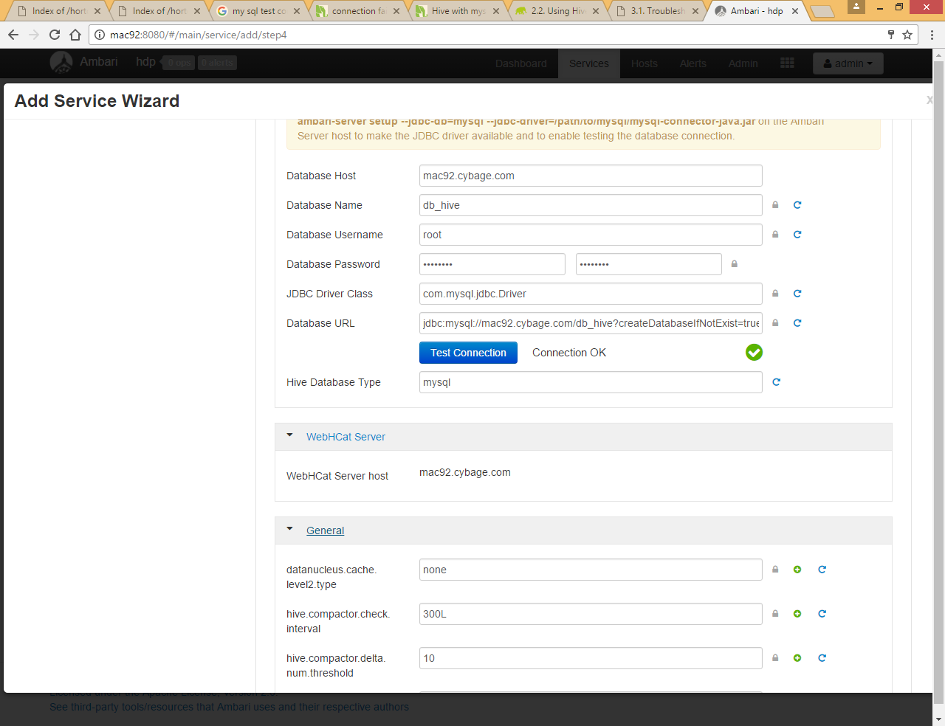

Now again click on Test connection

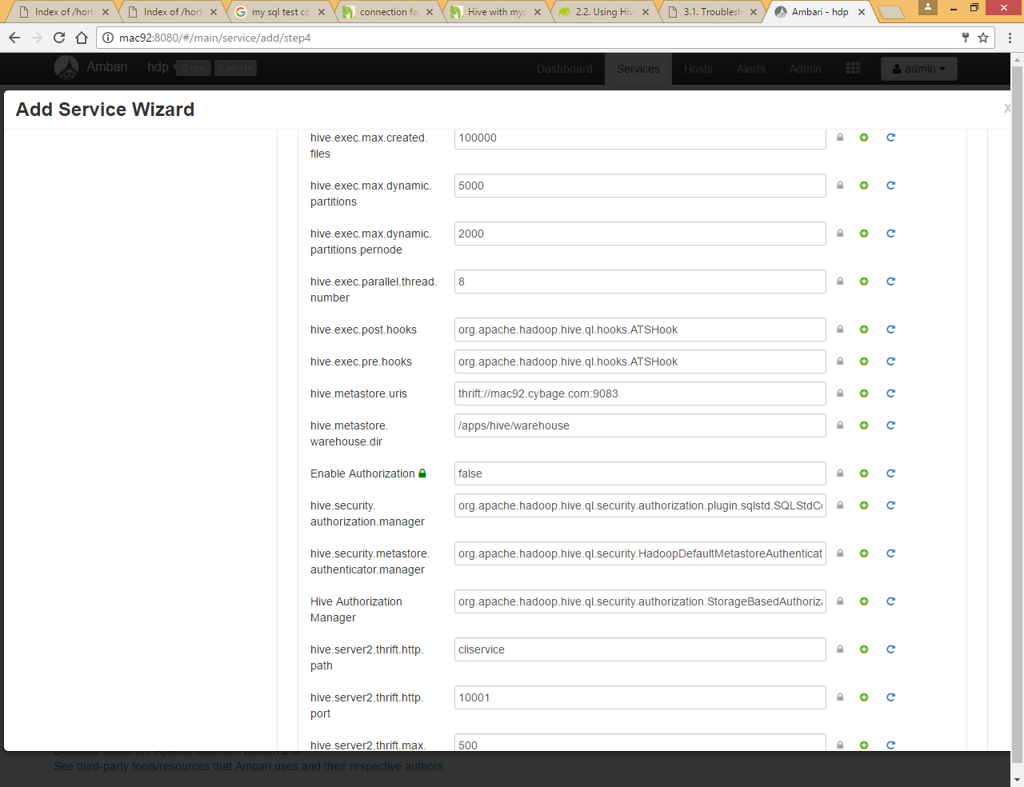

You can see default metastore directory path is **/apps/hive/warehouse** all managed tables going to store on that location

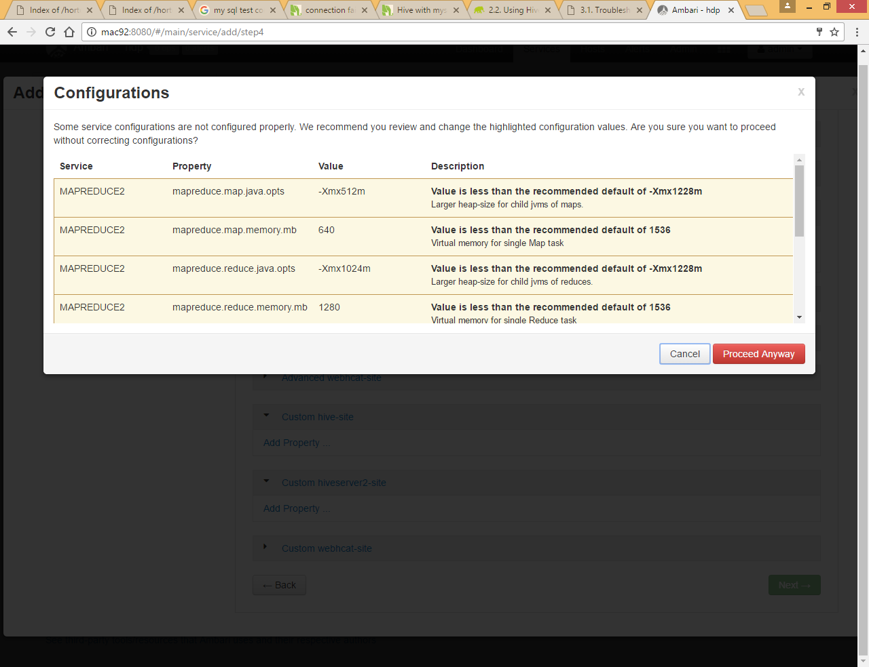

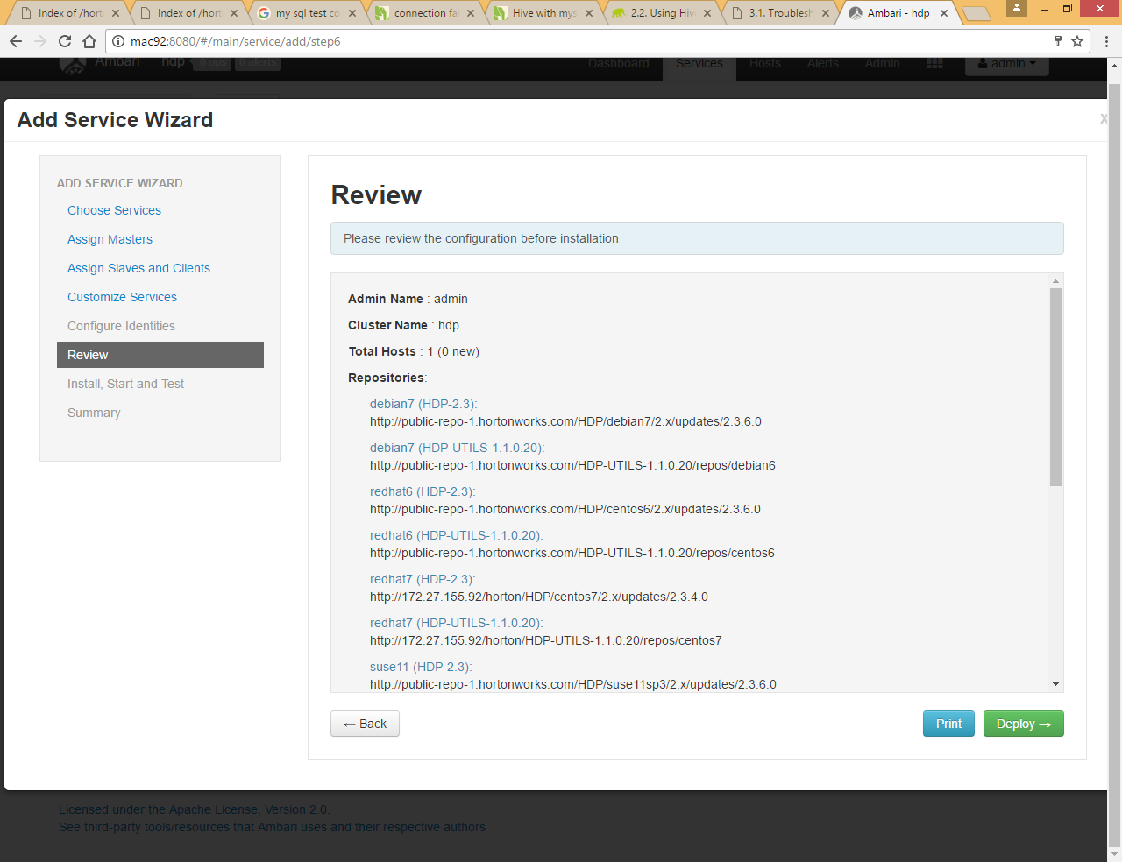

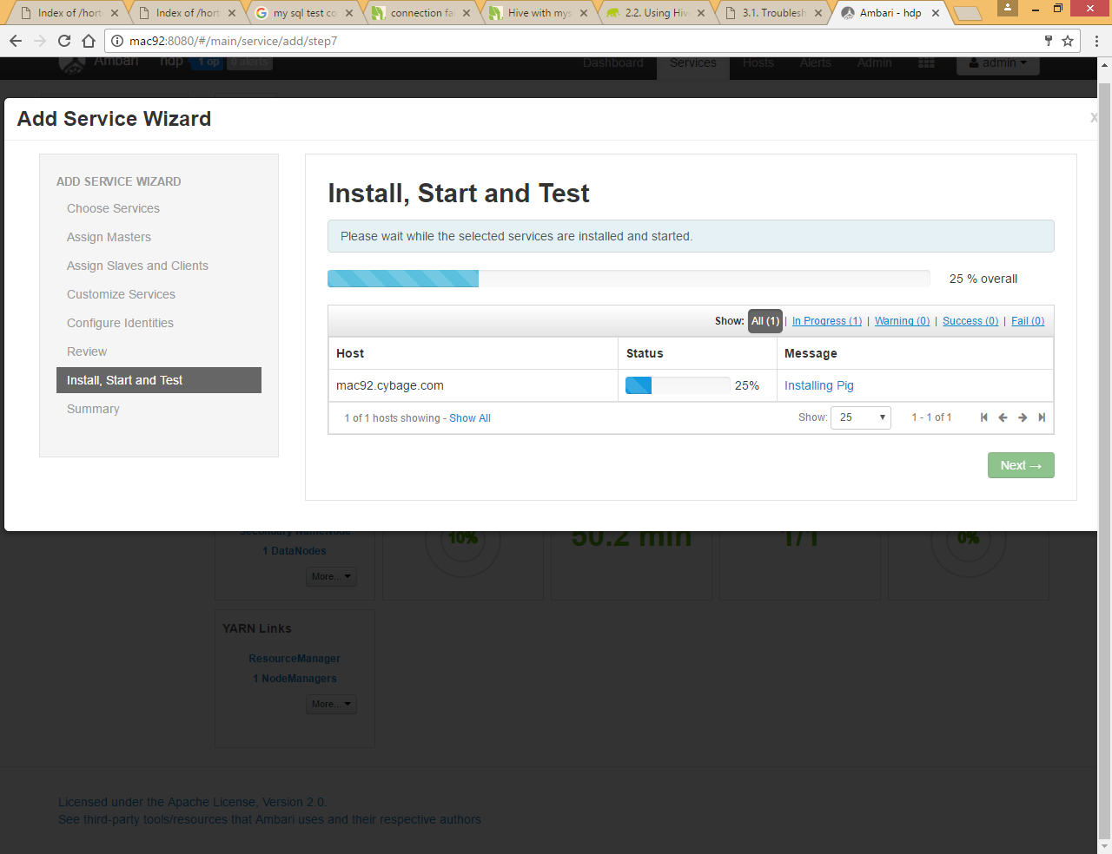

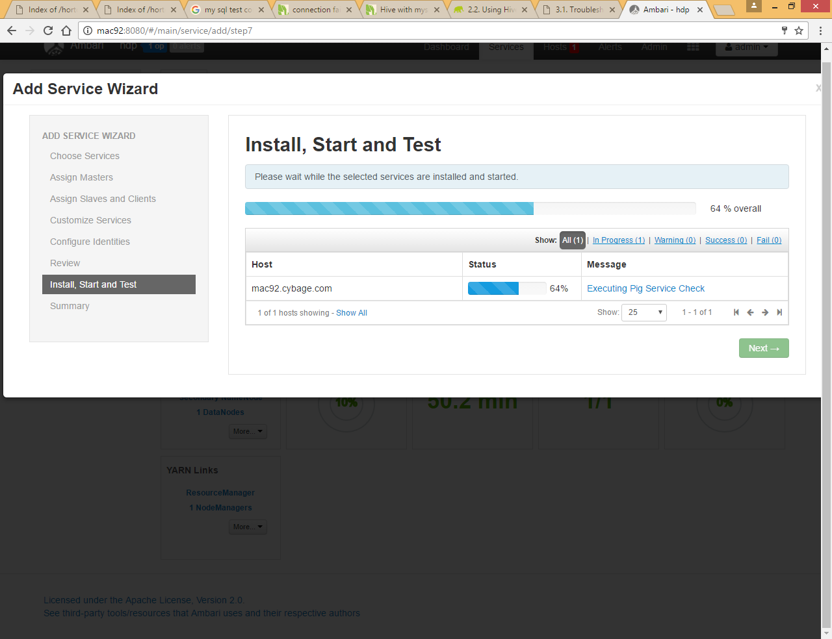

It check each component by executing some sample script

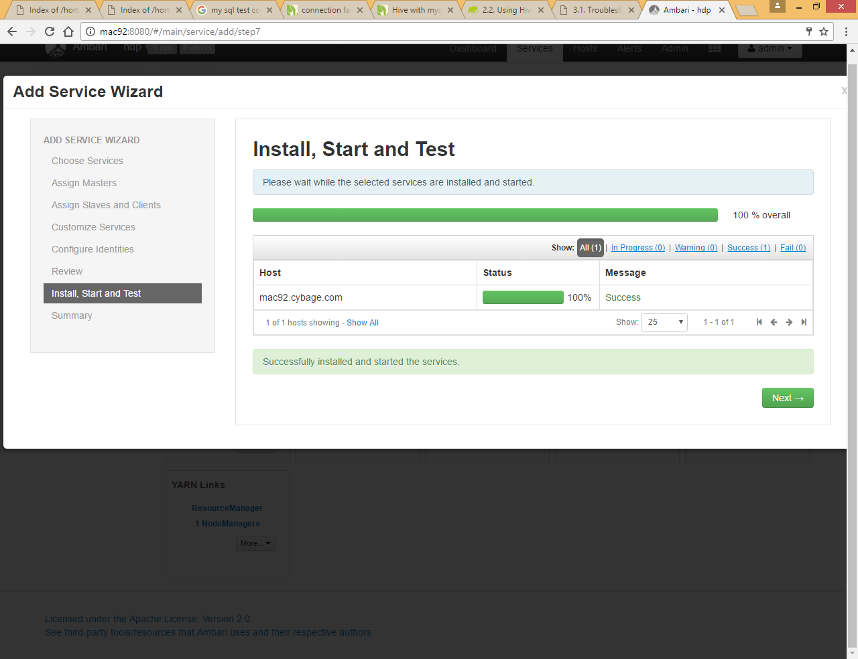

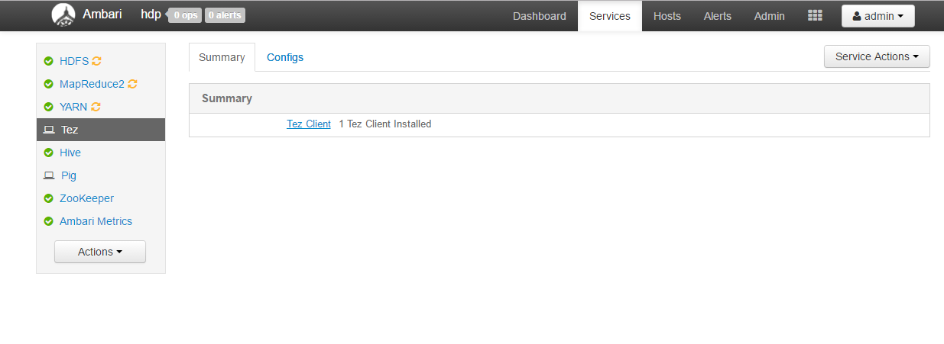

Here you can see  symbol it means we need to restart some stale services

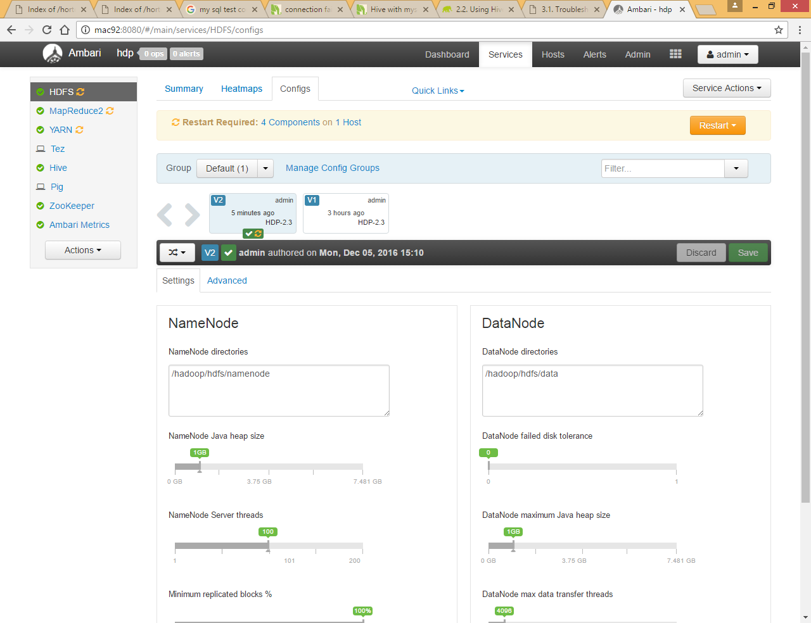

Click on that icon and click restart for all components one by one

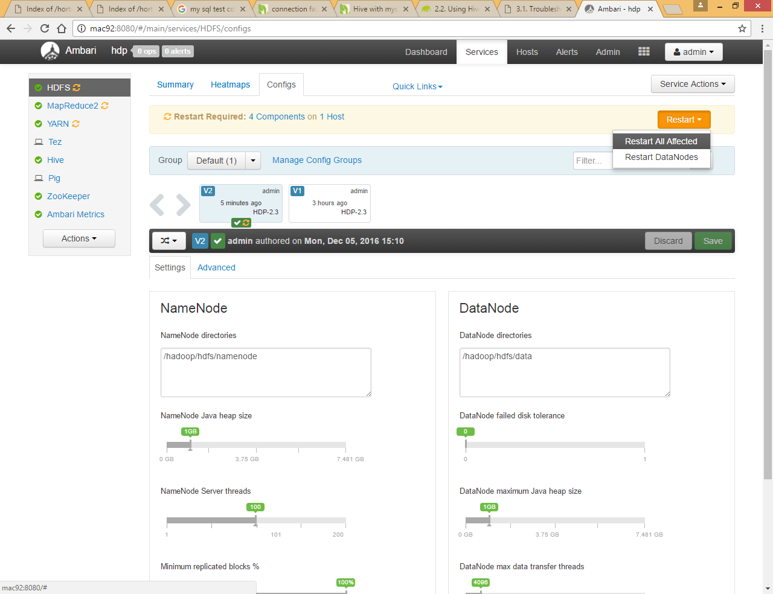

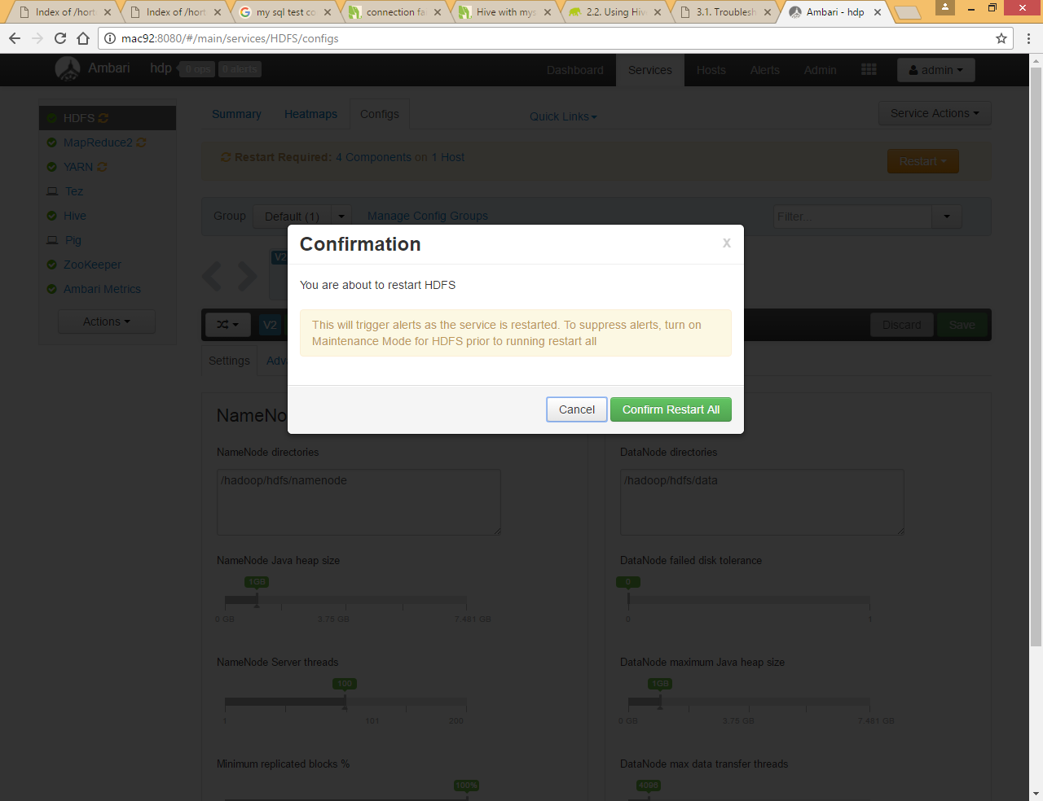

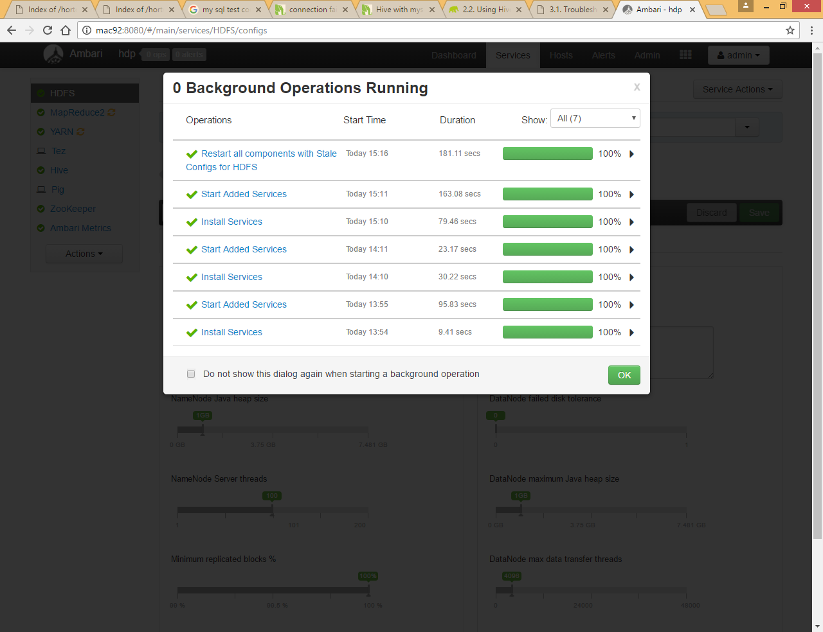

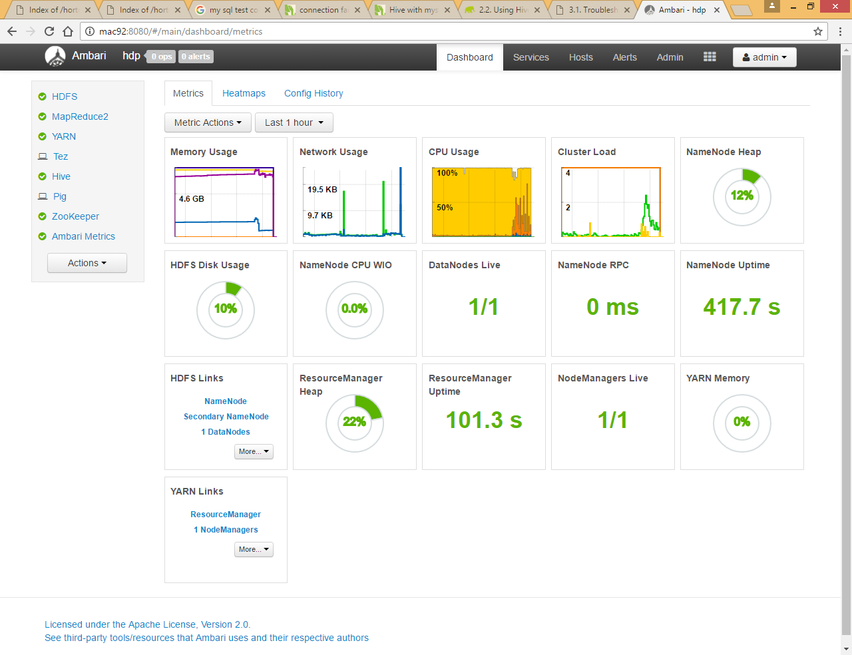

Check if hive is working on command prompt

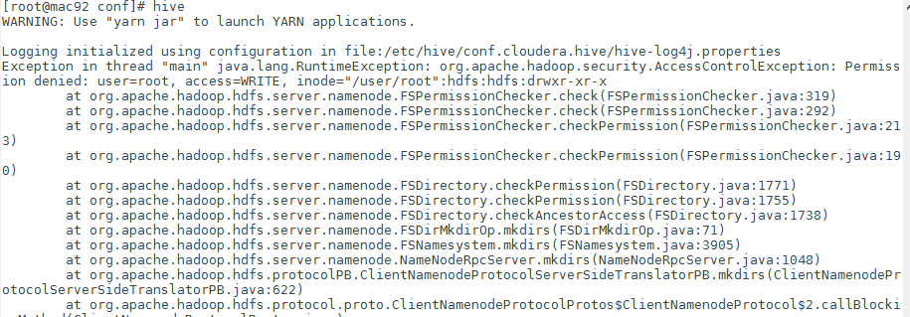

To resolve this issue run below commands

|  |
| --- |
| [root@mac92 conf]# sudo -u hdfs hadoop fs -mkdir /user/root  [root@mac92 conf]# sudo -u hdfs hadoop fs -chown root:root /user/root |